

**DEPARTMENT OF CIVIL ENGINEERING**

**CE410-CIVIL ENGINEERING DESIGN**

**FINAL DESING REPORT**

**Project: Design of a Pedestrian Bridge Over Kızılırmak (STR-1)**

**Advisor: Assoc. Prof. Dr. ALP CANER**



**Submission Date: 04.01.2017**

**ANKARA/2017**

Table of Contents

1. INTRODUCTION 8

1.1. Description of the Project 8

1.2. Aim and Scope of the Project 9

1.3. Vibration Phenomenon 10

1.3.1. Vibration Problem in Pedestrian Bridges 14

1.3.2. Analysis of the Current Bridge 15

1.4. Structural Features of the Bridge 21

2. DESIGN CRITERIA 22

2.1. Introduction 22

2.2. Codes and Standards 22

2.3. Structural Design Criteria 23

2.3.1. Design Loads 23

2.4. Design Bases 24

2.4.1. Allowable Stresses 24

2.4.2. Load Factors and Combinations 24

3. SYSTEM GEOMETRY 24

3.1. Dimensions 25

3.1.1. Detailed Drawings of the Members in the Bridge 27

4. STRUCTURAL ANALYSIS & DESIGN 30

4.1. Lump Sum Hand Calculations 30

4.1.1. Dead Load Calculation 30

4.1.2. Live Load Calculation 32

4.1.3. Stress Calculation on the I Beams 33

4.1.4. Calculation of the Forces Developing on the Main Ropes 34

4.1.5. Load Calculations on the Ropes Connected to Main Cables 36

4.2. Model Analysis 37

4.2.1. Defining the Geometry 37

For model analysis of this project instead of the conventional model program SAP2000, as Versatile group we have conducted the model analysis in LARSA4D, which is a modelling software specific for bridges is utilized, upon the decision taken by our group. 37

4.2.2. Loads and Load Combinations in Model 41

4.2.3. Model Runs and Results 41

4.2.3.1. Run without the Lateral Supports 42

4.2.3.2. Run with the Lateral Supports 43

4.2.3.3. Conclusion of the Modelling Results 45

4.3. Lateral Supporting Cable Design 46

4.4. Pylon Design 48

4.5. Cable Connection Design 50

5. GEOTECHNICAL DESIGN 51

5.1. Load Combination 52

5.2. Soil Profile 52

5.3. Foundation System 60

5.4. Gross and Net Foundation Pressure 60

5.5. Bearing Capacity 61

5.6. Settlement 62

5.6.1. Immediate Settlement 63

5.6.2. Consolidation Settlement 63

5.6.3. Total Settlement 64

5.7. Anchorage Blocks 64

6. MATERIAL SELECTION 66

7. COST ESTIMATION 66

Bibliography 70

Table 1. Dominant Frequencies in Three Dimensions 16

Table 2. Dominant Frequencies in Three Dimensions (with mass damping) 17

Table 3. Width to Span Ratios of Suspension Bridges 23

Table 4. General Dimensions of Avanos Bridge 25

Table 5. IPN-200 Sectional Properties 29

Table 6. Timber Properties 30

Table 7. IPN 300 Properties 30

Table 8. Upper Timber Properties 31

Table 9. Eigenvalue Analysis Results for Dominant Mode Shapes without Lateral Cable Supports 43

Table 10. Eigenvalue Analysis Results for Dominant Mode Shapes with Lateral Cable Supports 45

Table 11. Lateral Cable Lengths 47

Table 12. Water content and Atterberg limits 53

Table 13. SPT values 55

Table 14. Clay Parameters 61

Table 15. Is Values 64

Table 12. Cost Estimation of IPN 200 Beams Used in the Project 68

Table 13. Cost Estimation of IPN 300 Beams Used in the Project 68

Table 14. Bottom and Upper Timber Volume Calculations 68

Table 15. Timber Cost Estimation 69

Table 16. Pylon (HEM-450) Cost Estimation 69

Table 17. Main Cable Cost Estimation 69

Table 18. Vertical Cable Cost Estimation 69

Table 19. Concrete used in Foundation Cost Estimation 70

Table 20. Main Lateral Support Cables Cost Estimation 70

Table 21. Total Cost Estimation of the New Bridge 70

Figure 1. Satellite View of the Shaking Bridge in Avanos 7

Figure 2. Primitive Suspension Bridge made by Incans 8

Figure 3. Unsuccessful Solution for the Vibration Problem by Municipality 9

Figure 4. Simple Spring Mass System Equilibrium and Disturbed Positions 10

Figure 5. Effect of Damper on the System 11

Figure 6. Behaviour of Undamped Vibration 12

Figure 7. Behaviour of Damped Vibration 12

Figure 8. Longitudinal Frequency Vs Acceleration Graph 14

Figure 9. Transverse Frequency Vs Acceleration Graph 15

Figure 10. Vertical Frequency Vs Acceleration Graph 15

Figure 11. Longitudinal Frequency Vs Acceleration Graph (with mass damping) 17

Figure 12. Transverse Frequency Vs Acceleration Graph (with mass damping) 18

Figure 13. Vertical Frequency Vs Acceleration Graph (with mass damping) 18

Figure 14. Connections for Carrying Deck 19

Figure 15. Side View of the Avanos Bridge 24

Figure 16. Top View of the Avanos Bridge 24

Figure 17. Section View of the Bridge 25

Figure 18. Side and Section View of Upper Timber 26

Figure 19. Side and Section View of Timber 26

Figure 20. Side and Section View of the Beams 27

Figure 21. Side and Section View of the Beams 27

Figure 22. Side and Section View of the Pylons 28

Figure 23. Moment and Shear Diagrams Under Distributed Loading 33

Figure 24. Stress Distribution on a Beam Under Flexure 33

Figure 25. Suspension Bridge Forces in Main Ropes 34

Figure 26. Larsa4D 37

Figure 27. 3D view of the Suspension Bridge in LARSA4D 39

Figure 28. Side View of the Suspension Bridge in LARSA4D 39

Figure 29. 3D view of the Suspension Bridge in LARSA4D with Spring 40

Figure 30. Side view of the Suspension Bridge in LARSA4D with Spring 40

Figure 31. Linear Static Analysis Results of the one without Lateral Cable Supports(Stresses) 42

Figure 32. Linear Static Analysis Results of the one without Lateral Cable Supports(Deformations) 42

Figure 33. Linear Static Analysis Results of the one with Lateral Cable Supports(Stresses) 44

Figure 34. Linear Static Analysis Results of the one with Lateral Cable Supports(Deformations) 44

Figure 35. Millennium Bridge Visualization 46

Figure 36. Tension Values at the Main Rope 48

Figure 37.Hanger Cable Connection to Main Cable 50

Figure 38. Connection of Hanger Cables 51

Figure 39. Soil Profile 53

Figure 40. USCS Soil Classification for Coarse Grained Soil 54

Figure 41. USCS Soil Classification for Fine Grained Soil 54

Figure 42. f1 vs PI graph 56

Figure 43. f2 vs PI graph 56

Figure 44. Φ’ vs PI graph 57

Figure 45. a* factor 57

Figure 46. Casagrande’s Method for determining preconsolidation stress 58

Figure 47. Chart for estimating correlation factor, Kc 59

Figure 48. The Skempton and Bjerrum correction factor 60

Figure 49.Plasticity index - Eu/N60 relationship (Poulos and Small, 2000) 60

Figure 50. Skempton's Nc Values 63

Figure 51.Settle 3D values 65

Figure 52. Excel Calculations for Block Design for main supporting cables 66

Figure 53. Excel Calculations for Block Design for lateral supporting cables 66

# INTRODUCTION

## Description of the Project

This pedestrian bridge project is conducted specifically for the Shaking Bridge which is located in Avanos, Nevsehir by Versatile Engineering. Avanos is located in the Central Anatolia region of Turkey and situated in the historic Cappadocia region. Kizilirmak river, which is the longest river in the Turkey, separates Avanos from Cappadocia. As a result of being such a tourist destination any problematic situation caused by this bridge will cause a great deal of economic issue in this region, since the major livelihood of this region depends on the touristic attributions.

Shaking Bridge is a pedestrian bridge, which was built around 1974 and since than it has been unsteady. It provides a connection between two sides of the Kizilirmak. As it can be seen in Figure 1. It is obvious that while being constructed, no one expected it to last that longer and be a trademark of Avanos. The unstable situation of the bridge makes it a tourist destination and Avanos is benefitting from this current situation. However, it has been realized that as much as it benefits the district, the unstable behavior of the bridge under pedestrian walking makes it a time bomb, not knowing when will it explode.

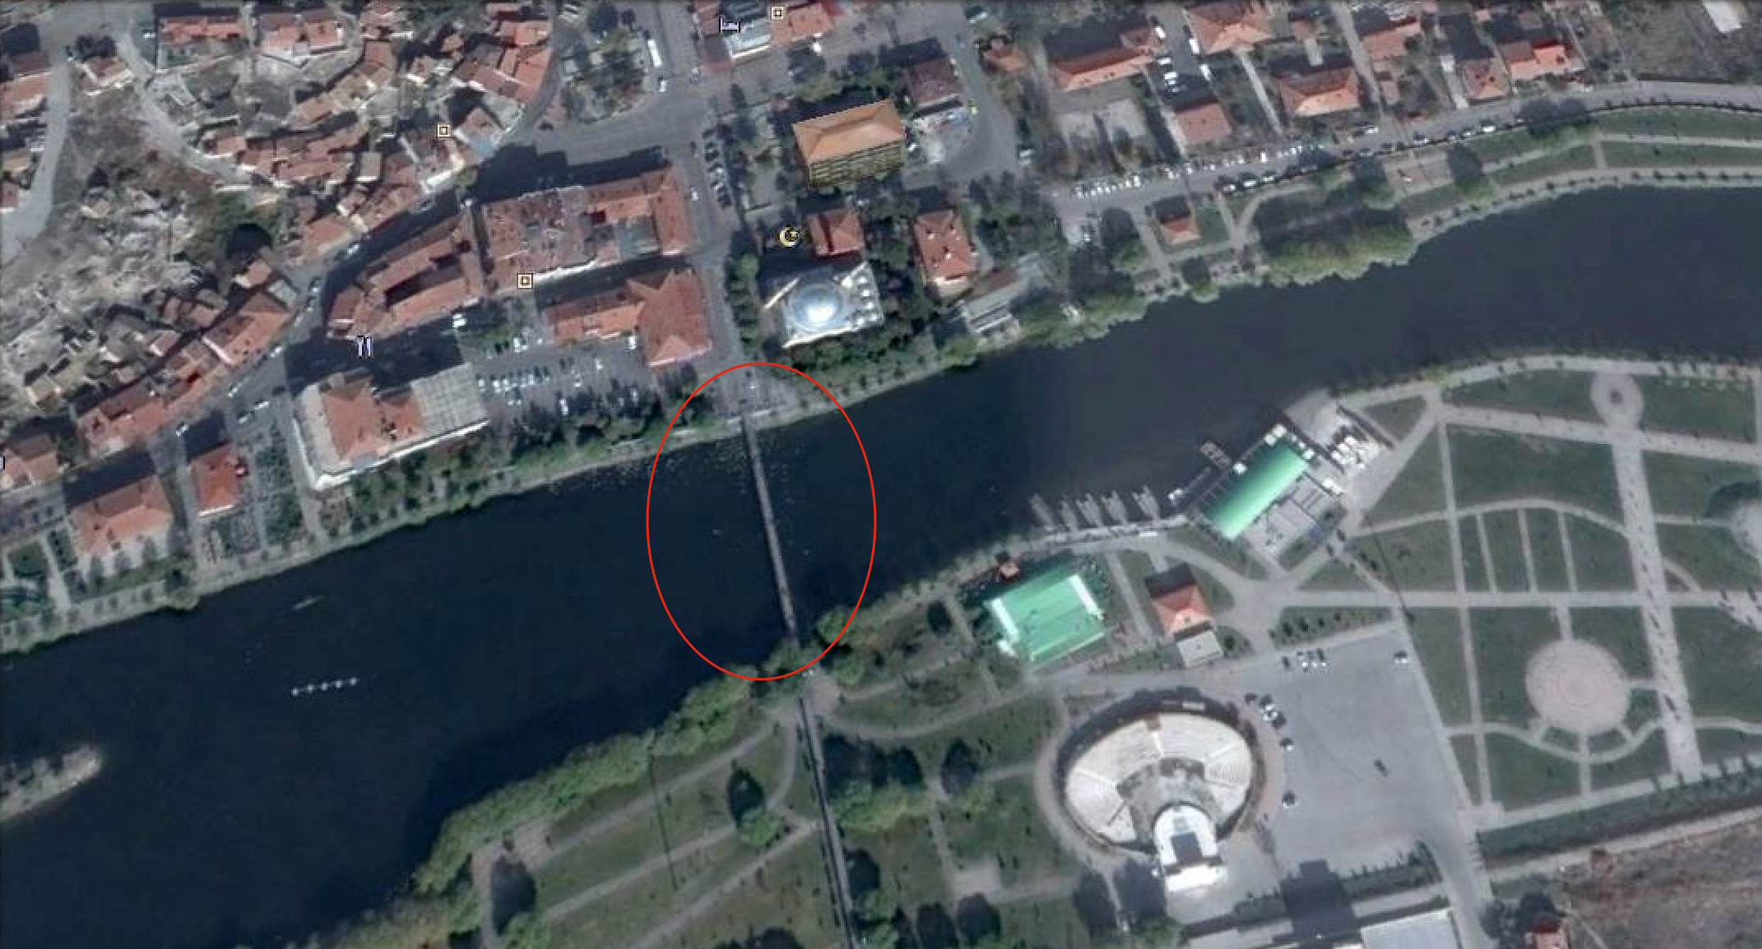

Figure 1. Satellite View of the Shaking Bridge in Avanos

## Aim and Scope of the Project

Aim of this project is determined to be stabilizing the bridge while allowing some vibration in order not to block the tourist attention if it is possible or designing a new suspension bridge similar to the old one without any safety issue, upon the request of the mayor of Avanos. High density of tourists increases the risk of failure and creates major serviceability problems, by creating nausea like sensation while passing over the bridge. Upon the site visit it has been observed that even 3 people walking with the same period creates an incredible amount of wobbling effect on the bridge.

The Shaking Bridge is a suspension bridge, which is one of the oldest engineering techniques, that are used by the primitive people, as shown in Figure 2 and got stronger with the use of iron in the cables in 4th century by Indians. Moreover, suspension bridges provide an economic solution over long spans of navigable channels (Encyclopedia Britannica, n.d.).

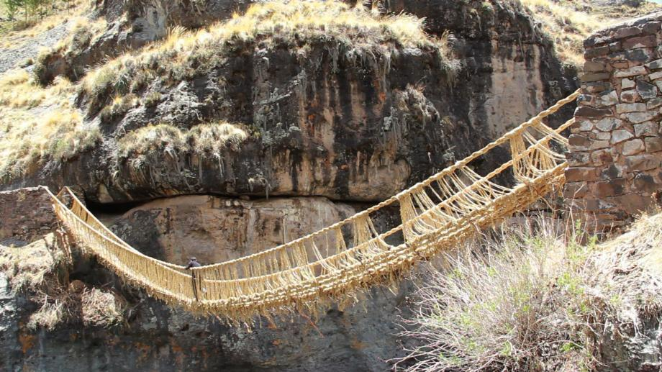

Figure 2. Primitive Suspension Bridge made by Incans

Shaking Bridge in Avanos is constructed as a suspension bridge in order to enable the gondola service with ease and minimizing the cost. Shaking Bridge consist of two parts one on the Kizilirmak river and in the continuation of that part there exist a part on the land. The problematic part of the bridge is the former one, since the portion that is stretching out on the land is stabilized by connecting the bridge to the land. Moreover, it should be noted that same solution is tried to be applied to the problematic portion as well by putting rock blocks and connecting the bridge to these blocks by spring ended cables (see Figure 3), but this solution did not work, in addition architect of the municipality believes that this solution technique caused some deformation on the middle span of the bridge, which as a result increases the vibration problem in the long run.

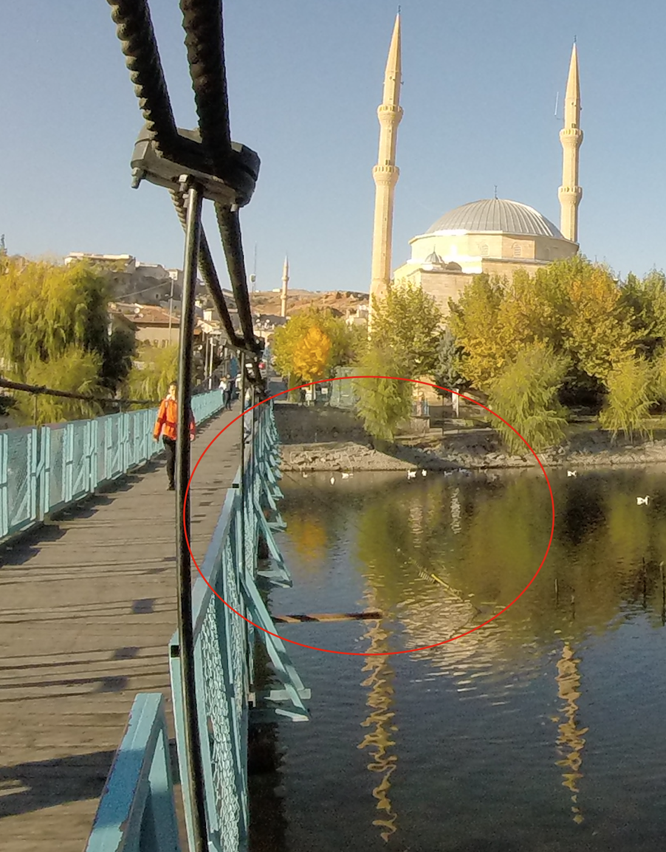

Figure 3. Unsuccessful Solution for the Vibration Problem by Municipality

## Vibration Phenomenon

Vibration is the periodic motion of any particle in an elastic body, which is back and forth. This phenomenon occurs when a body is disturbed from its equilibrium, and allowed to react to the external forces that tend to reconstruct its equilibrium position (Encylopedia Brittannica , 2016), This could best be understood with the spring-mass example as it can be seen in Figure 4. If the system is disturbed from its equilibrium position it tends to go back to the equilibrium position, this back and forth motion continuous until all the kinetic and potential energy is lost due to frictional forces. This motion of the spring-mass system is defined as the simple harmonic motion. If there are no frictional forces acting on the system, it will move in a sinusoidal motion through time as it can be seen from Figure 4.

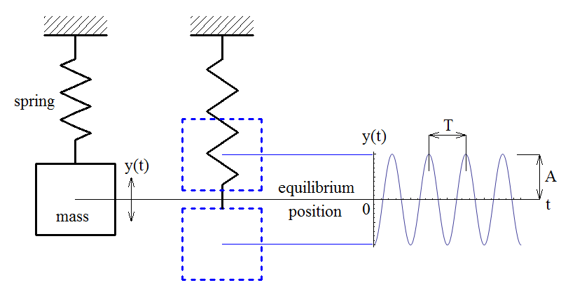

Figure 4. Simple Spring Mass System Equilibrium and Disturbed Positions

The main damper of this kind of systems are frictional forces and these forces amortise the energy and enable the spring mass system to go back to his equilibrium position. However, it should be noted that the dampers do not avoid the object to go into undisturbed state it just enables the system to absorbed the energy induced by the external forces, the dampers amortizing ability will depend on the dampers internal features and the external forces’ magnitude. Moreover, natural frequency of this spring motion can be calculated using the equation given below (CHAN);

$$f=\frac{1}{2π}*\sqrt{\frac{k}{m}}$$

It should be noted that according to this equation without changing the stiffness of the object or the mass of the object it could be impossible to change its natural frequency.

Every rigid object has a structural resonance frequency, which is a frequency when entered the particles in that object wants to vibrate more, the best example of this situation is the urban myth of an opera singer, shattering a goblet with her voice alone. This situation can be explained in comprehensible way; the sound of the person is the result of the vibration of the vocal chords of that person, which travels in the air with a certain frequency if that frequency is in the range of the goblet the particles in the goblet starts to vibrate, and when the frequency of the soundwave reaches exactly the natural frequency of the goblet, it starts to vibrate more and more. If this state could be provided a few seconds theoretically the goblet particles depart from each other, which leads to the shattering of the goblet. This state of the object is called resonance. It should be noted that this phenomenon is almost analogous for the large objects like buildings as well, which could enter resonance with wind and earthquake forces. In order to avoid dangerous situations big buildings are made by considering these kind of effects by engineering and architectural expert cooperation (Things of Interest, 2011).

In order to, understand the concept of resonance, natural frequency and effect of damper see Figure 5.

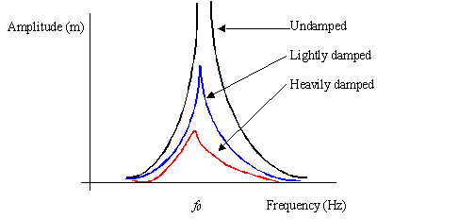

Figure 5. Effect of Damper on the System

As it can be seen from the Figure 5 if the frequency range of one object coincides with the other objects natural frequency range they both start to act as one and vibrate together. Moreover, damper usage only decreases the amplitude of the vibration in spring case deformation of the spring, but it does not create full absorption of the exerted force, which means dampers could only be used in order to decrease the effect of vibration, not for wiping out the vibration problem.

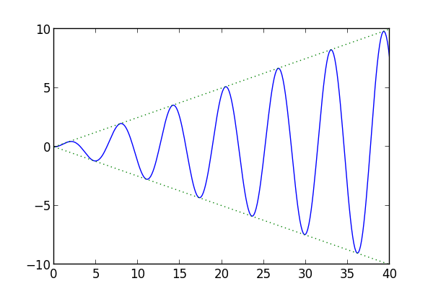

Figure 6. Behaviour of Undamped Vibration

Damper, behaviour is also should be known in order to limit the problems caused by the vibration. As it can be seen in the Figure 5 if there is no damper the vibration amplitude goes to infinity, which means the total energy cannot be consumed. Another visualisation for better understanding the phenomenon is provided in Figure 6. However, when the damper is used the amplitude of the vibration can be fixed to a value and vibration could be taken under control until a certain point. Vibration behaviour could be observed in Figure 7.

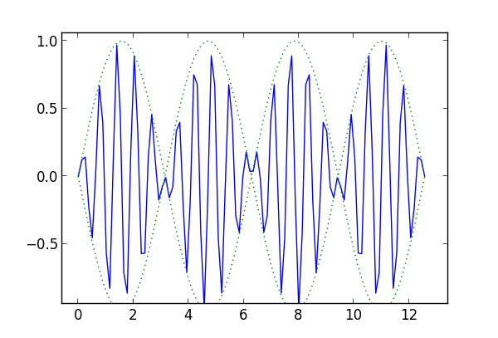

Figure 7. Behaviour of Damped Vibration

As it can be seen the amplitude of the vibration is fixed to a value and it never exceeds that fixed value.

## Vibration Problem in Pedestrian Bridges

In recent past there a lot of pedestrian bridges that have experienced large amplitude pedestrian- induced vibrations. Main cause of this phenomenon is the low mass, stiffness and damping. The most recent and known example of this phenomenon is the Millennium Bridge in London, which has closed immediately after the vibration complaints. Vibration in that case was the result of the large number of people passing the bridge, which starts synchronized walking motion after a while (Ricciardelli F. , 2007).

It is obvious that pedestrian movement is a very complex motion which introduces a complex system of forces on three dimensions, which are changing in space and time, depending on the physical attributes of the pedestrian (Ricciardelli F. , 2016). It should be noted that the Shaking Bridge in Avanos is designed in such a way that the human induced forces are assumed to be acting as structural loads by ignoring the dynamic behavior. Moreover, it has been observed that bridge motion modifies the actions that are exerted by the pedestrians. The basic effect of this vibration on the pedestrians are discomfort nausea like symptoms, which are serviceability issues of the structures. Furthermore, it should be noted that what makes modelling of the pedestrian walking on the bridge so complex is taking into consideration of both inter-pedestrian and pedestrian-bridge interactions, in addition to that there are synchronized and incoherent groups of people at the same time while some people just try to force the bridge to vibrate (Ricciardelli F. , 2016).

Recently, modern and architecturally appealing bridges are being constructed all over the world, but while being modern and aesthetic their weights are reduced significantly, moreover, this weight reduction is caused by the increased material capacities too. Thus, these lightweight bridges have low mass inertia, which in turn drastically decreases the natural frequency of the structure. It is known that if the natural frequency of the structure line up with the frequency of the excitation a resonance phenomenon occurs. Pedestrians induce an unsteady, transient and swaying excitation on the bridge in a small range of frequency, which is between 1 and 2 hertz (Hz). Moreover, vibrations are effective in three dimensions (RWTHAACHEN University).

Thus, according to the subjects mentioned above the natural frequency of the structure should not match with the pedestrian induced frequency range in order to be stable in 3 directions.

## Analysis of the Current Bridge

A field trip has been conducted with the Professor Alp Caner and his PhD. student Nefize Saban, in order to observe the current situation of the bridge and found the natural frequency of the bridge with the help of accelerometers.

After taking measurements and conducting a Fast Fourier Transform (FFT) Analysis, Nefize Saban had given the graphs in Figure 8,Figure 9 and Figure 10 that shows the natural dominant frequencies of the bridge in 3 directions. It should be noted that FFT analysis coverts a signal from time and space in to the frequency. It should be noted that a1, a2 and a3 indicates the longitudinal, transverse and vertical direction respectively.

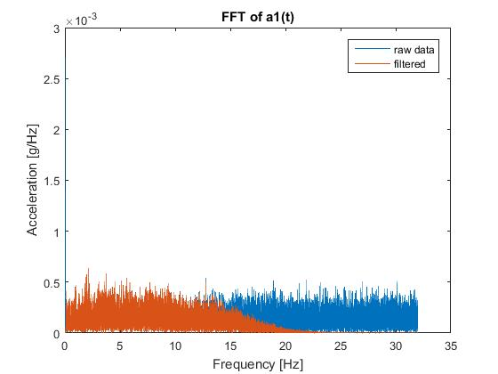

Figure 8. Longitudinal Frequency Vs Acceleration Graph

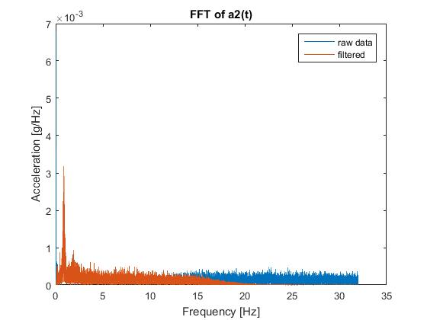

Figure 9. Transverse Frequency Vs Acceleration Graph

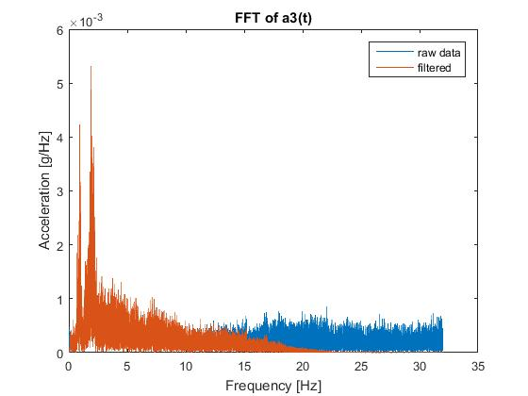

Figure 10. Vertical Frequency Vs Acceleration Graph

As it can be seen from the above graphs the dominant Frequencies can be listed as shown in Table 1 ,

Table 1. Dominant Frequencies in Three Dimensions

|  |  |
| --- | --- |
| Direction | Frequency(Hz) |
| Longitudinal | 2.1162 |
| Transverse | 0.82715 |
| Vertical | 1.9092 |

As it can be seen in Table 1, dominant frequency of the bridge is found between 1 and 2 Hz, which means natural frequency of the bridge lines up with the pedestrian walking frequency. This situation will cause the bridge to wobble with the people walking on it. In addition to this fact, the bars that, that connects I Beams under the deck to the suspended ropes of the bridge, are subjected to 1800 cycle in 250 seconds. The cycle number that leads to failure is approximately 107 cycles according to ASM International Fatigue Resistance of steels handbook. So,

$$Cycle per day=\frac{1800 \left(cycle\right)*3600 \left(seconds\right)*24 (hours)}{250 \left(seconds\right)*1 (hours)}=622080 cycles/d$$

$$Days until Failure=\frac{{10}^{7}(cycles)}{622080 (cycles/d)}=16 days$$

As it can be seen from the calculations one bar fails in approximately 16 days which is a very optimistic number, since the mayor of Avanos had stated that at least one bar fails in a week.

After the calculation of the natural frequencies of the bridge, in order to see how it would react to damping another measurement is made with hanging 4 bags of 10 kg additional weight 20 on one side and 20 on the other side. Vibration measurements are taken from the bridge as it can be seen in Figure 11, Figure 12, and Figure 13. Moreover, the dominant frequencies can be found in Table 2.

Table 2. Dominant Frequencies in Three Dimensions (with mass damping)

|  |  |
| --- | --- |
| Direction | Frequency(Hz) |
| Longitudinal | 2.1162 |
| Transverse | 0.82715 |
| Vertical | 1.9092 |

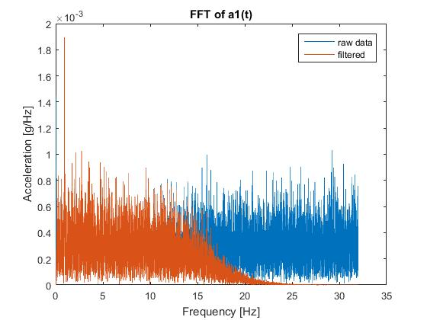

Figure 11. Longitudinal Frequency Vs Acceleration Graph (with mass damping)

As it can be seen in although the mass dampers are added the dominant frequency could not be changed, so it is concluded that the mass damping solution for the vibration problem cannot solve the existing vibration problem. Moreover, there is a limit for mass damping since the load carrying capacity of the bridge has a limit.

Other than natural frequency and fatigue of the steels, current suspension bridge pylons are 3.8 meters which is very small. Moreover, it should be noted that there is not any written information about the bridge, so the rope strengths, tension in the ropes, or bars are not known, in addition; the connections used in the bridge in order to carry the deck are very susceptible to fatigue which do not enable any motion in the longitudinal direction as it can be seen in Figure 14.

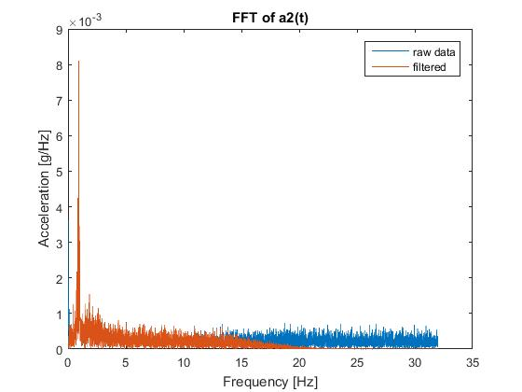

Figure 12. Transverse Frequency Vs Acceleration Graph (with mass damping)

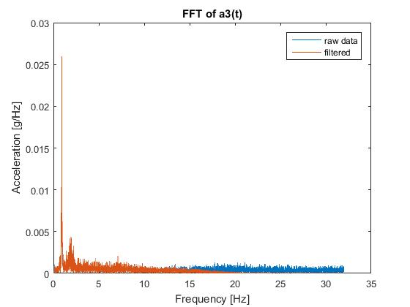

Figure 13. Vertical Frequency Vs Acceleration Graph (with mass damping)

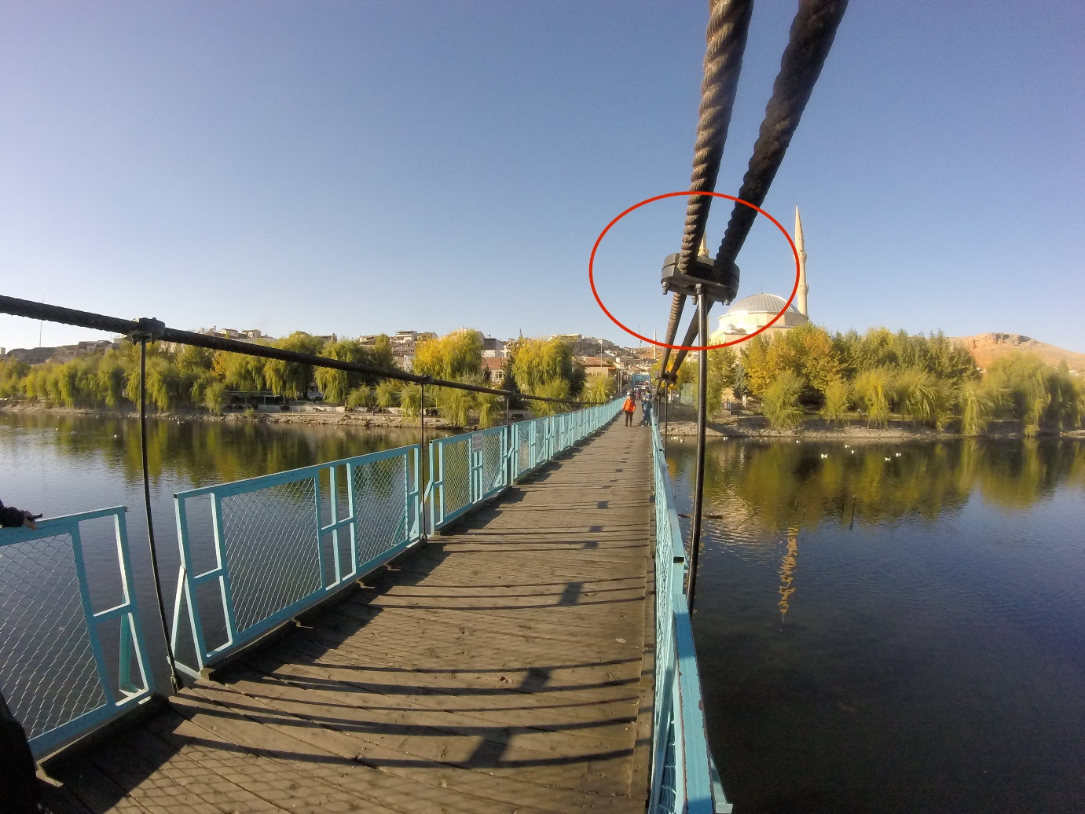

Figure 14. Connections for Carrying Deck

As stated above the dominant natural frequency of the current suspension bridge is found between 1-2 Hz, which coincides with the pedestrian walking frequency causing the bridge to vibrate, during the bridge crossing of the pedestrian. The first thought was to add dampers and minimize the amplitude of the vibration, however, this application only reduces the amplitude of the vibration. So, this would not be a solution to the bridge vibration, moreover; after some point the usage of the dampers will negatively affect the bridge, since the mass of the dampers should be manageable in order to be carried by the bridge itself. It is evident that without playing with the mass or stiffness of the bridge, frequency of the bridge cannot be increased and separated from the frequency range of the walking pedestrians.

By considering all the mentioned factors above it has been decided to design a new bridge from start in order to create a more stable and safe transportation for all the pedestrians that are passing through the bridge every day. The construction year and lack of document existing about the bridge makes increasing the mass or playing with the stiffness of some elements. Thus, the final verdict is that, design and construction of a new bridge will be a more effective solution, than trying to solve the vibration problem of the current suspension bridge with the dampers. This project will also help the municipality since, it has been stated that, municipality is planning to build 3 more bridges across the Kizilirmak. So, from this point on this paper will focus on the design of a new pedestrian bridge in 90-meter length in order to provide safe and stable transportation for the people.

## Structural Features of the Bridge

It has been decided that construction of another suspension bridge will not disturb the aesthetic and authentic visualization of the area and it will create a little vibration compared to other bridge techniques like cable stayed bridges, moreover, it will definitely be less costly, since it this bridge technique does not utilizes the new technologies like pre-tensioning or post tensioning. Furthermore, it has been decided that the bridge will be very similar to the old one in order to be cost effective and familiar to the local residents. During the field trip it has been observed that the local residents like passing thru this bridge, although it wobbles.

It should be noted that there will be no piers in the stream in order to provide sufficient room for gondolas to pass underneath the bridge, which is another reason why the suspension bridge is selected.

Advantages of suspension bridges are as follows (ConnectUS, 2015);

* The main advantage of the suspension bridges is the fact that its construction is very inexpensive, the materials used are very basic which are anchorages connections and ropes, considering the budget limitation of the municipality it is very crucial to make a safe bridge with the least cost.
* Ease of maintenance work is another advantage of the suspension bridges; this type of bridges does not need any major constructional maintenance work over long time periods which again makes it appealing considering the budget of the municipality.
* Bearing the earthquake loads is another important feature of the suspension bridges, their flexible features enable the bridge to vibrate and wobble during the earthquake, freely.

Disadvantages of suspension bridges are as follows;

* Suspension bridges are very susceptible to wind loads because of their flexibility.
* Limited load carrying capacity compared to other type of bridges is the main disadvantage of this type of bridges, however; for a small province like Avanos this disadvantage becomes problematic when the tourist number is very high.

By considering all the advantages and disadvantages in addition to the current situation of the Avanos, cable stayed bridge construction seams very feasible.

# DESIGN CRITERIA

## Introduction

This document includes the codes and standards and criteria that will be used in the CE-410 Project of the Versatile Group, which has a footbridge project in Avanos, that has a vibration problem. More particular information about the project will be given in the final report of the project.

## Codes and Standards

The design and control of this engineering project will be done according to the design specifications of the pedestrian bridge which is published by the American Association of State Highway and Transportation Officials. In case of any missing or conflicting information requirements of the more conservative documents will be used in order to be on the safe side.

* LRFD Guide Specifications for the Design of Pedestrian Bridges
* AASHTO LRFD
* AASHTO Signs
* Suspended Pedestrian Bridge Design and Analysis

## Structural Design Criteria

## Design Loads

* Dead Loads;

Dead loads include the complete weight of the structure and all the equipment that is used for fastening or connecting structural elements.

* Pedestrian Load (Live Load);

Live loads include the load of the people that are passing through the bridge, since the bridge is not suitable for vehicle entrance only pedestrian loads will be considered.

AASHTO LRFD specifications uses a base nominal loading of 85 psf without considering the influence area, since we are using LRFD specifications these accepted pressures are factored using LRFD load factor which is 1.75 (American Association of State Highway and Transportaion Officials, 2009).

$$1.75*85=149 psf$$

It should be noted that there is a physical limitation for the maximum pedestrian loading which is taken as 150 psf. Pedestrian bridges are to be designed for a uniform loading of 90 psf – 4.31 kPa, this amount of load is patterned on the bridge to produce the maximum load effects. Combining this with load factor;

$$1.75*90=158 psf$$

It should be noted that taking the nominal live load capacity as 90 psf gives borderline, but sufficient pressure estimation compared with the maximum credible pedestrian loading which is taken as 150 psf –7.18kPa. (American Association of State Highway and Transportaion Officials, 2009)

* Wind Loads;

Wind load is taken as the force caused by pressure of 0.02 ksf which is equal to 0.957 kPa over the full deck width which is applied at the same time, facing the wind at the quarter point of the deck width.

## Design Bases

## Allowable Stresses

Calculated stresses in any member of the structure caused by different loading combinations will not exceed the maximum allowable stresses permitted by the applicable codes.

## Load Factors and Combinations

1.2 factor will be used for dead load and no factor will be used for live load and no factors will be used for wind load

# SYSTEM GEOMETRY

From what we have seen when we went to the bridge, the width of the bridge which was 2.3 m was not enough when large group of people are crossing. Therefore, we wanted to enlarge it to 3,5 meters. Our bridge has 90 meters’ span length. Some of the suspension bridges in our country has these longest span/width ratios shown in the Table 3. According to, average of these ratios our bridge should be 3 meters. However, we wanted it to be wider in order to ease the crossing of crowded groups and also we wanted our bridge to be heavier to make it period higher.

Table 3. Width to Span Ratios of Suspension Bridges

|  |  |  |  |
| --- | --- | --- | --- |
| Bridges | Longest Span | Width | Ratio |
| Fatih Sultan Mehmet | 1090 | 39 | 0.036 |
| Yavuz Sultan Selim | 1408 | 58.5 | 0.041 |
| Bosphrous | 1074 | 33.4 | 0.031 |
| Osman Gazi | 1550 | 35.93 | 0.023 |
| Avanos | 90 | 2.96 | 0.032 |

## Dimensions

The height of the suspension bridge towers above deck is dependent on the sag to span ratio which can vary from about 1:8 to1:12. A good preliminary value is about 1:10 (Wai-Fah Chen, 1999). Therefore, we selected our bridge towers height above the deck as 9 meters and below the deck it is 3.5 meters as shown in the Figure 15Figure 15.

The sag ratio is taken as L/20 (Bridges to Prosperity, 2009). Then at the middle point of our bridge, the height of the main rope from the deck is 4.5 m. However the tension at the main cable came out very large when sag is 4.5 m, therefore we decided it to increase 8 m.

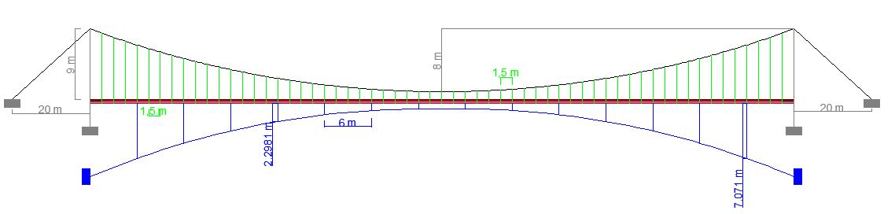

Figure 15. Side View of the Avanos Bridge

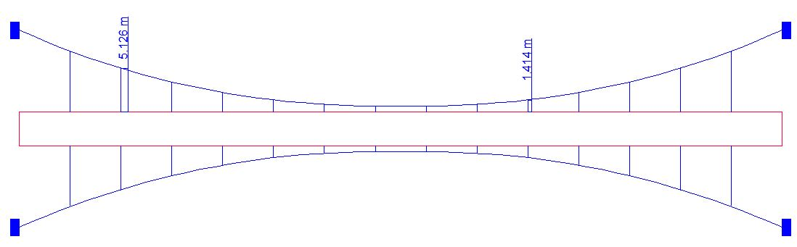

Figure 16. Top View of the Avanos Bridge

General dimensions of our bridge is tabulated in the Table 4.

Table 4. General Dimensions of Avanos Bridge

|  |  |
| --- | --- |
| Avanos Bridge General Dimensions | |
| Span Lengths (m) | 90 |
| Pylon Heights (m) | 12,5 |
| Pylon Type | H |
| Width (m) | 3,5 |
| Sag Length (m) | 8 |

Our bridge has upper timbers that pedestrians walk through. Another timber section that is under upper timber that will be nailed to the upper timber and placed on the IPN beams, in order to keep upper timbers together and to spread the load to the IPN sections. We selected IPN 200 steel sections, which have 1.5 m spacing between them, will be connected to main ropes of our bridge. At the sides of the IPN 200 sections we will weld IPN 300 along the bridge to keep the deck compact. Section view of our bridge at the middle point is shown in the Figure 17.

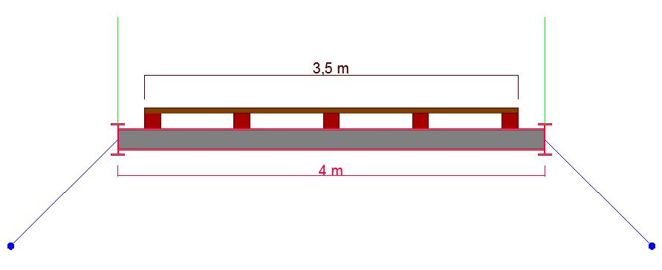

Figure 17. Section View of the Bridge

## Detailed Drawings of the Members in the Bridge

* Upper Timbers

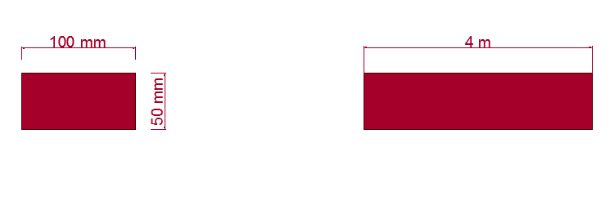

Figure 18. Side and Section View of Upper Timber

Upper timber is shown in the Figure 18. It has 5 cm depth, 10 cm width and 4 meters length. It is the layer that people will step on it. Whole cross section of the bridge deck will be layered with this timber. It will be nailed to the timbers underneath.

* Timber

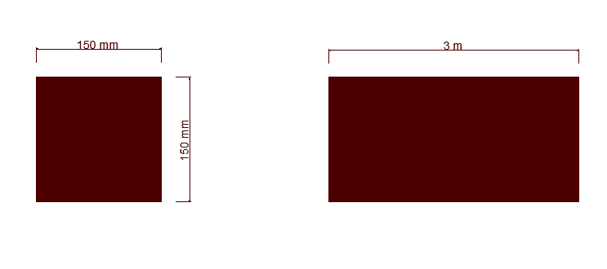

Figure 19. Side and Section View of Timber

Timber will be placed under the upper timber. As it is shown in the Figure 19, it has square section with 15x15cm. Its length will be 3 meters and it will be attached to the top of the IPN 200 sections. It will distribute the load to the IPN 200 sections. Five pieces of them will be used along with the whole span as it is shown in the Figure 17.

* IPN 200

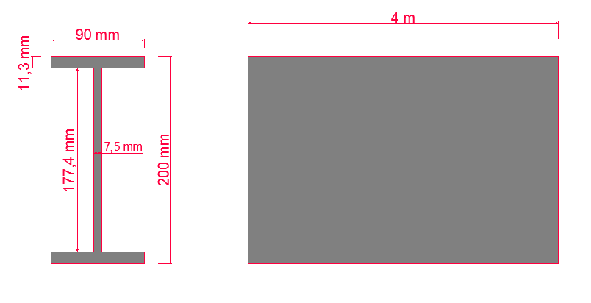

Figure 20. Side and Section View of the Beams

As it is shown in the Figure 20 we will be using IPN 200 sections. Its length is 4 meters. Flange thickness is 11,3 mm and it has 7,5 mm web thickness. The height of the section is 200 mm. This section will carry the load and transfer it to the main rope by vertical ropes. There will be fifty-nine of them in our bridge. They will be placed with 1.5 m spacing.

* IPN 300

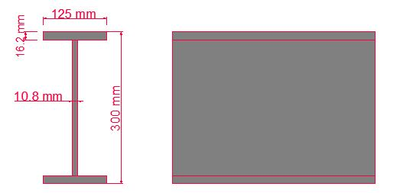

Figure 21. Side and Section View of the Beams

As it is shown in the Figure 21 we will be using IPN 300 sections. Its length will be 90 meters along the bridge at the both sides. Flange thickness is 16.2 mm and it has 10.8 mm web thickness. The height of the section is 300 mm. This section will be welded to the IPN 200 section and main rope will be connected to this section.

* Pylons

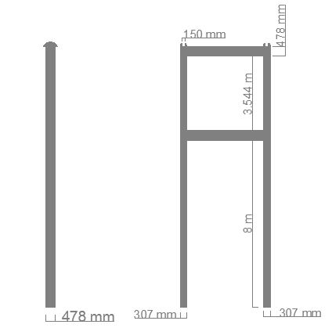

Figure 22. Side and Section View of the Pylons

In the Figure 22, our pylons’ dimensions are given. Its total height is 12.5 meters. 9 meters of the height will be above the deck and 3.5 meters will be below. HEM450 section will be used for pylons. There are places at the top of our pylons for the main ropes to seat them.

# STRUCTURAL ANALYSIS & DESIGN

## Lump Sum Hand Calculations

It should be noted that there are several things to be checked for the preliminary design which are forces in the main rope, stresses in the I Beams are the main focus in this preliminary calculations. For these calculations to be made the dead load and the live load should be determined meticulously. However, it should be noted that these calculations are very rough and the results of these calculations will only be used for having a rough information about the general behavior and the founding the needed strengths of the materials that ae going to be selected.

Calculations in this point are very rough as stated and done only statically. Detailed calculations will be done with the help of a software, while investigating the dynamic behavior of the structure, and the results of this second part will be presented in the final report.

## Dead Load Calculation

For calculation of the dead loads unit weight of the selected steel parts and density of the wood is used.

* I-Beams;

As stated before IPN-200 type of I Beams are selected, Basic Properties of the selected beam is shown in Table 5.

Table 5. IPN-200 Sectional Properties

|  |  |  |  |  |  |
| --- | --- | --- | --- | --- | --- |
| I Beam | | | | | |
| IPN 200 | Sx (m3) | Quantity (#) | Length (m) | Total Length (m) | Unit Weight (kg/m) |
| 0,000214 | 59 | 4 | 236 | 26,2 |

$$Total Length=Quantity*Length=59*4=236 (m)$$

$$Total Weight=Total Length*Unit Weight=236*26,2=6183.2 (kg)$$

* Timber on the Beams;

Basic properties of the Timber are shown in Table 6.

Table 6. Timber Properties

|  |  |  |  |  |
| --- | --- | --- | --- | --- |
| Timber | | | | |
| Quantity (#) | Height (m) | Width (m) | Length (m) | Density (kg/m3) |
| 5 | 0,15 | 0,15 | 90 | 670 |

$$Volume of Timber=Height*Width*Length=0.15*0.15*90=2.025 m^{3}$$

$$Total Weight=Volume*Density=2.025*670=6783.75( k)g$$

* IPN300;

Basic properties of the selected bottom steel are given in Table 7.

Table 7. IPN 300 Properties

|  |  |  |
| --- | --- | --- |
| IPN 300 | | |
| Quantity (#) | Length (m) | Unit Weight (kg/m) |
| 2 | 90 | 54.2 |

$$Total Weight=Quantity*Length*Unit Weight$$

$$Total Weight=3*90*54.2*=14634 (kg)$$

* Upper Timber;

Basic properties are given in

Table 8. Upper Timber Properties

|  |  |  |  |
| --- | --- | --- | --- |
| Upper-Timber | | | |
| Height (m) | Width (m) | Length (m) | Density (kg/m3) |
| 0,05 | 3,5 | 90 | 670 |

$$Volume of Timber=Height*Width*Length=0.05*3.5*90=15.75 (m^{3})$$

$$Total Weight=Volume*Density=15.75*670=10552.5 (kg)$$

As a result of these calculations the total force acting on 1 m2 area can be calculated as follows;

$$Total Weight \left(kg\right)=Total Weight of Timbers\left(kg\right)+Total Weight of Steel(kg)$$

$$Total Weight \left(kg\right)=6183.2+6783.75+14634+10552.5=38153,45 (kg)$$

$$Total Dead Load Weight \left(kN\right)=Total Dead Load \left(kg\right)*g (m/s^{2})*{10}^{-3}$$

$$Total Dead Load \left(kN\right)=38153,45 \left(kg\right)*9.81 \left(\frac{m}{s^{2}}\right)*{10}^{-3}=374,285 (kN)$$

Calculations in order to find the stress caused by all of the dead load on the deck, are shown below;

$$Stress=\frac{Total Dead Load}{Area}=\frac{374,285}{90*3.5}=1,188 (kPa)$$

It should be noted that the beams cover 4 meters, but the deck that people can walk is 3.5 meters long, so the stress is calculated by using 3.5 meters.

## Live Load Calculation

It is stated in the design criteria that the live load should be 150 psf, which is equal to 7.18 kPa. Detailed explanation can be found in design criteria section of this report.

## Stress Calculation on the I Beams

It should be noted that the dead load is factorized with a rough coefficient in order to include the weight of the safety rail and the connecting cable weights.

Total stress on the deck is calculated as,

$$Total Stress on the Deck=1.2*Dead Load+Live Load$$

$$Total Stress on the Deck=1.2*1,188+7.18=8,61 (kpa)$$

Note that 1.2 is a factorization for the LRFD Guide;

In order to find the stress caused by the flexure, finding the distributed load acting on one beam is a must, so

$$Distributed Load on a I Beam=Total Stress on the Deck*Length of the Deck$$

$$Total Distributed Load on I Beams=8.61 kPa*90 m= 774,9(kN/m)$$

$$Total Distributed Load on a I Beam=\frac{774,9}{59}=13,13 (kN/m)$$

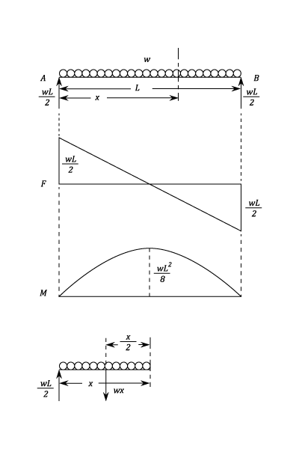

Figure 23. Moment and Shear Diagrams Under Distributed Loading

As shown in Figure 23 Beams are under distributed loading and the maximum moment occurs in the middle of the beam and can be calculated as follows;

$$M_{d}=\frac{\left(W_{g}+W_{q}\right)*L^{2}}{8}$$

$$M_{d}=\frac{13,13*4^{2}}{8}=26,26 (kN*m)$$

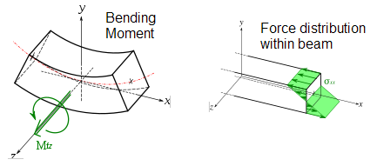

Figure 24. Stress Distribution on a Beam Under Flexure

After, moment calculation the maximum stresses, which are compression on top and tension on the bottom, as it can be seen from the Figure 24, that will develop on the top fibers of the beam could be calculated as follows;

$$σ_{max}= \frac{M_{d}}{S_{x}}$$

$$σ_{max}= \frac{26.26* {10}^{3}}{214*{10}^{-6}}=122.7 MPa$$

So, if the Steel with yielding capacity higher than 122.7MPa is selected the beam will be safe under the most extreme dead load and live loads.

## Calculation of the Forces Developing on the Main Ropes

There is tension in the main ropes and compression on the pylons, there is 2 components of the tension force on the rope which are vertical and horizontal, as shown in Figure 25.

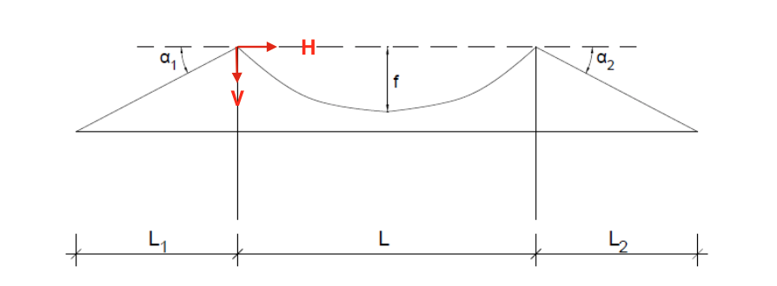

Figure 25. Suspension Bridge Forces in Main Ropes

It should be noted that the forces on the main ropes can be calculated using the following formulations (Bridge Turkey Organization, 2016);

$$V=\frac{\left(W_{g}+W_{q}\right)*L}{2}$$

$$H=\frac{\left(W_{g}+W_{q}\right)*L^{2}}{8*f}$$

$$T (Resultant Force)=\sqrt{V^{2}+H^{2}}$$

Distributed load in the 90 meters’ span should be found first to be used in this calculation so,

$$Distributed Load on 90 m Span=Total Stress on the Deck*Width of the Deck$$

$$Distributed Load on 90 m Span \left(W_{g}+W_{q}\right)=8.61 \left(kPa\right)*3.5\left(m\right)=30.12 ( kN/m)$$

So the total forces on the main ropes can be calculated as shown below, moreover; it should be noted that it has been decided that four main ropes will be used in this bridge so the total force is divided equally between 4 ropes

$$V_{Total}=\frac{30.12*90}{2}=1355.4 (kN)$$

$$V_{One Rope}=\frac{1355.4 (kN)}{2}=677.7 (kN)$$

$$H_{Total}=\frac{30.12*{90}^{2}}{8*8}=3812.063 (kN)$$

$$H_{One Rope}=\frac{3812.063 (kN)}{2}=1906,1 (kN)$$

The resultant force in one rope can be calculated as follows;

$$T=\sqrt{{1906,1 }^{2}+{677.7}^{2}}=2022.99(kN)$$

So, if all the ropes are selected with the design load greater than $2023$ kN the bridge safely carries all the loads applied on it.

## Load Calculations on the Ropes Connected to Main Cables

Total load of the deck and the live load is transferred to the main cable of the suspension bridge, with the help of these ropes, and they share the load equally between them, so the load on one rope can be calculated as follows;

$$T_{vertical}=\frac{Total Stress on the Deck*Area of the Deck }{\# of Ropes }$$

As mentioned in the bridge geometry part of this report there will be ropes connected to the all I beam on either sides of the beam, so

$$\# of Ropes=\# of Beams*2$$

$$\# of Ropes=59*2=118 ropes$$

Thus, load on one vertical rope can be calculated as;

$$T_{vertical}=\frac{8.61(kPa)*(3.5*90) }{118 }=22.984 (kN/rope)$$

So, if the design load of the selected cable is higher than 23 kN, ropes will safely hold the deck and the people on it in the most extreme conditions.

It should be noted that the above calculations are very raw calculations, since this report is a preliminary report, which has the aim to give general concepts of and these calculations are going to be detailed in the final report.

## Model Analysis

## Defining the Geometry

# For model analysis of this project instead of the conventional model program SAP2000, as Versatile group we have conducted the model analysis in LARSA4D, which is a modelling software specific for bridges is utilized, upon the decision taken by our group.

LARSA4D is a software committed to providing the best structural engineering solutions and to accommodate each client's unique and changing engineering needs. In commercial use for over 25-years, LARSA's high quality analysis engine provides the latest in computing technology. LARSA's 4D BRIDGE SERIES software provides a unified 3D finite element environment for the analysis, design and rating of bridges without the need to purchase additional tools.



Figure 26. Larsa4D

It should be noted that this program is very like AutoCAD, with user interface, however, the concept and the inputs are very different than it. The most obvious thing that stands out is that, one should have define the geometric objects in the space as points in a spread sheet provided in the software, so the usage of excel with this program is highly recommended for fast and precise geometric creation and utilization. Again, it should be noted that in this program only 2 points in the space can be connected to draw a line, one cannot draw a line, as he/she likes.

So, the model analysis started with creation of the main cable, the basic assumption that is made in this calculation is that the main cable has a parabolic shape and it could simply be represented by the following equation;

$$y=ax^{2}$$

so, in order to define the parabola one should find a coefficient and it could simply be found by using the points on the main cable, it is known from the system geometry part that for y=8m, x=45m, by assuming that the middle point on the main cable is x=0 and y=0 point, so a can be calculated as follows;

$$a=\frac{8}{{45}^{2}}=3.951*{10}^{-3}$$

$$y=3.951*{10}^{-3}*x^{2}$$

After finding the equation of the main cable points with the interval of 1.5 m are found in excel spread sheet and copied to the geometric properties spread sheet of the Larsa. After that, the deck is constructed 1 m below the middle point of the main cable for 45 meters left and 45 meters right. Now, the frame work of the bridge is done now it’s just a matter of deciding what type of elements to be used. For example, for cable a truss type of elements are modeled since it is known that the main cable is on tension and carries only tension, there is no moment on the cable, moreover the hanger cables are also modeled as a truss member. And the IPN members are selected and defined into the software as described in system geometry part. Moreover, the last hanger cables in the 90th meter of the bridge and 0th meter of the bridge is defined as pylons of the bridge and fixed to ground at bottom. And the continuing, part of the cables are also designed as truss member as specified in the system geometry part and fixed. And the related parameters can be seen in appendix of the report. The defined system could be seen geometrically in Figure 27 and Figure 28.

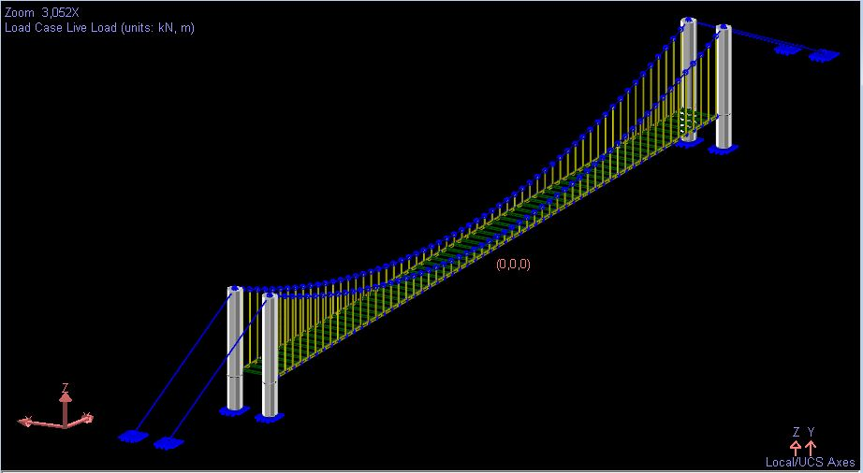

Figure 27. 3D view of the Suspension Bridge in LARSA4D

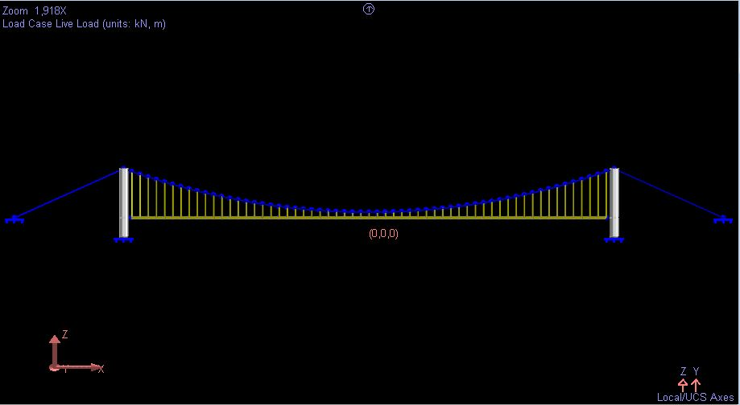

Figure 28. Side View of the Suspension Bridge in LARSA4D

As it is stated in the introduction part the main aim of this project was to solve the vibration problem of the suspension bridge, since almost all the suspension bridges have this problem, which have low stiffness like in our case, so in order to solve this situation 2 cases have been considered one without the lateral supporting cables and one with the lateral supporting cable.

It should be noted that lateral supporting cables are modeled as springs on the system since upon application of any load from left or right one cable will always be in tension resisting the motion of the deck, which resist the motion of the bridge deck against the direction that any force acts on the bridge. Application of this supporting can be seen in detail on the system geometry part. Geometric design of the bridge can be seen in Figure 29, Figure 30.

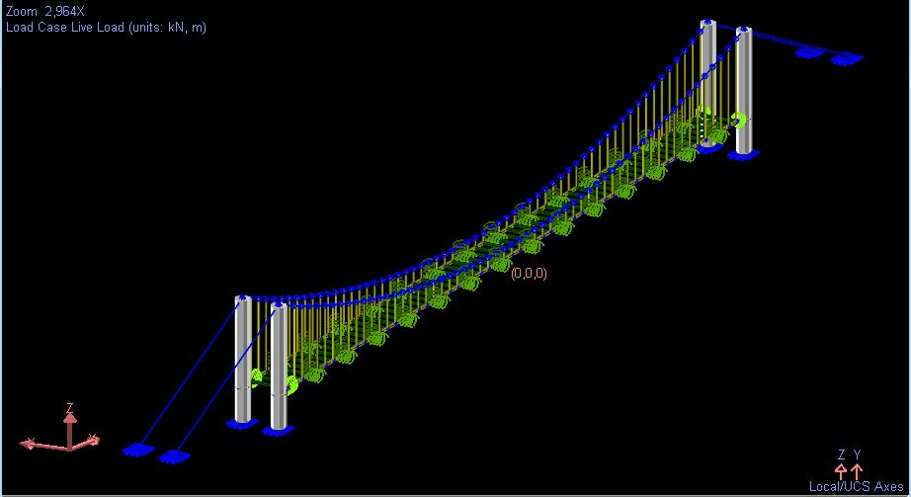

Figure 29. 3D view of the Suspension Bridge in LARSA4D with Spring

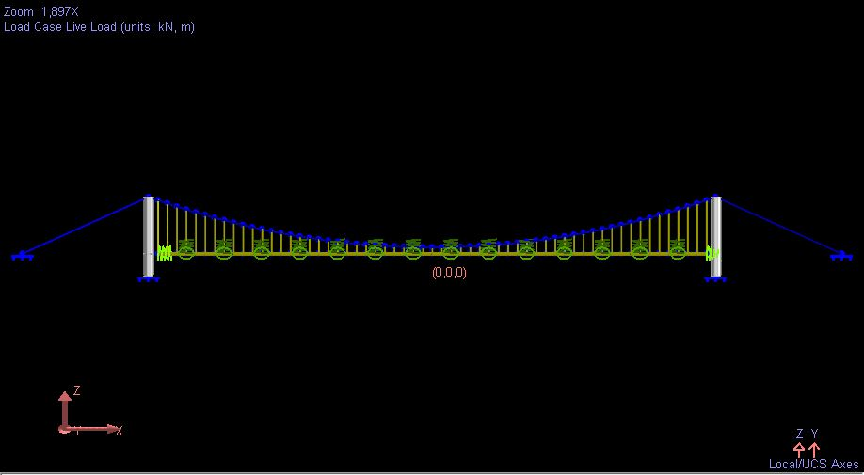

Figure 30. Side view of the Suspension Bridge in LARSA4D with Spring

In addition to supporting cables above figures shows 4 springs on the x axis too, which are introduced to the system as mass dampers on the x axis.

## Loads and Load Combinations in Model

Self-weight of the structural members is defined in software itself, moreover, since in this software one can put loads on the joints total live load on the bridge, which is 7.18 kPa, is divided equally on to joints as shown below;

$$Live load on one Joint=\frac{7.18*3.5*90 (kPa)}{118 (\# of joints)}=19.17 kN$$

and the wind load is calculated as 0.957 kPa and this load is defined in the system as distributed load in the lateral area of the deck as follows;

$$Uniform Wind Load on the Deck=\frac{0.957}{0,3(Web Height of the IPN300) }=0,288 kN$$

And Load Combination that will be used is defined in the Design Specification part of the project.

$$Load Combination=1.2 Dead Load+1 Live Load+1 Wind Load$$

## Model Runs and Results

It should be noted that 2 different cases are present first one is the one without the lateral supporting cables and the second one is with the lateral cable support. Moreover, since it is the most critical case of them all only 1 most critical loading case will be run and the results will be shown accordingly and the model run is done on 2 different aspects first one is the Linear Static Analysis and the other one is Eigenvalue Analysis, former is for determining the loads and stresses on each structural element and the latter one is for the determination of the vibrational properties of the bridge for 100 mode shapes. Finally, it should be noted that the more general results are provided in the appendix.

### Run without the Lateral Supports

Linear Static Analysis have given the results shown in Figure 31 and Figure 32.

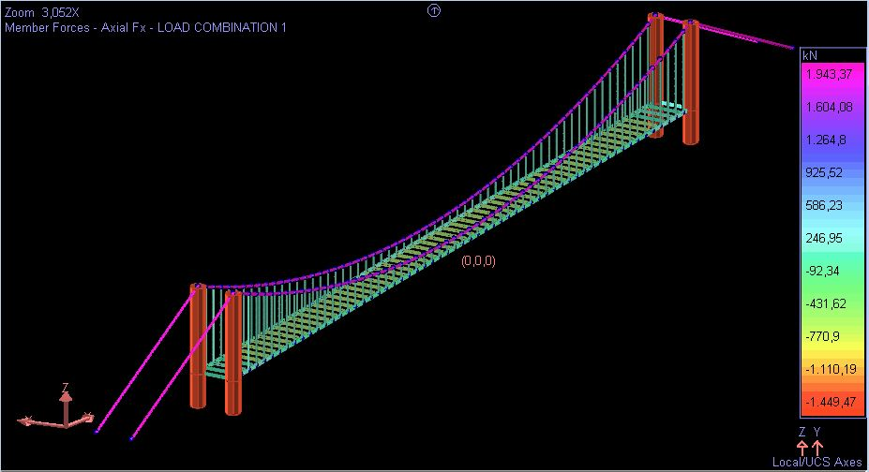

Figure 31. Linear Static Analysis Results of the one without Lateral Cable Supports(Stresses)

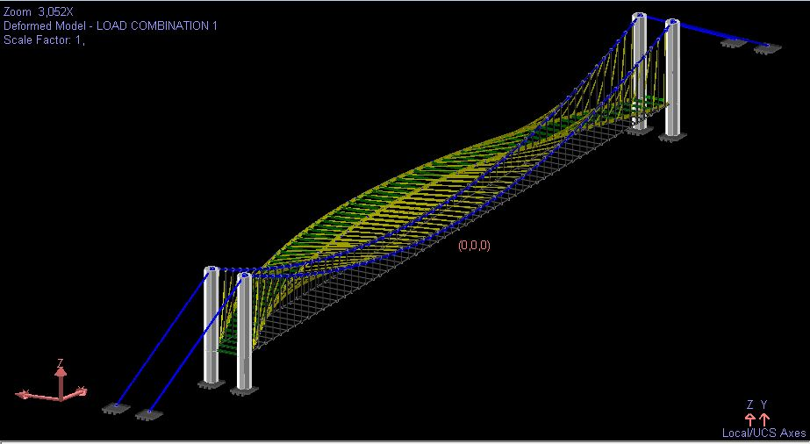

Figure 32. Linear Static Analysis Results of the one without Lateral Cable Supports(Deformations)

As it can be seen above the maximum stresses develop along the cables in tension which is very like the ones calculated by hand, which are almost 2000 kPa by hand and almost 1944 kPa with the model. Moreover, it can be seen in Figure 32 that upon the application of the wind load the bridge is swinging like a crane.

After the Eigenvalue analysis for 100 mode shapes most critical modes and their respective frequencies could be seen in Table 9.

Table 9. Eigenvalue Analysis Results for Dominant Mode Shapes without Lateral Cable Supports

|  |  |  |  |  |  |
| --- | --- | --- | --- | --- | --- |
| Mode Shape | Frequency (Hz) | Period (s) | Per Mass X | Per Mass Y | Per Mass Z |
| M1: f = 0,09, t = 10,6121 | 0,0942 | 10,6121 | 0,0000 | 20,8378 | 0,0000 |
| M34: f = 3,46, t = 0,2893 | 3,4567 | 0,2893 | 0,0000 | 0,0000 | 52,5926 |
| M47: f = 5,5, t = 0,1818 | 5,5000 | 0,1818 | 0,0000 | 21,4872 | 0,0000 |
| M94: f = 15,7, t = 0,0637 | 15,7043 | 0,0637 | 69,0805 | 0,0000 | 0,0000 |

Moreover, in Y axis frequency of the bridge is very low, thus there exists a vibration problem in 1st mode shape. As stated in the frequency phenomenon parts aim in the vibration problem is to increase the frequency of the bridge over 2 s-1 and according to the LRFD Guide for Pedestrian Bridge Design frequency should be bigger than 3 s-1, in order to get out of the natural frequency of the walking pedestrians, below that limit there will be serviceability problems because of the swinging like feeling of the bridge. The current situation of the existing bridge is similar to this case too, however; existing bridge has lower frequencies since its stiffness is lower than the one that is modeled.

### Run with the Lateral Supports

Linear Static Analysis have given the results shown in

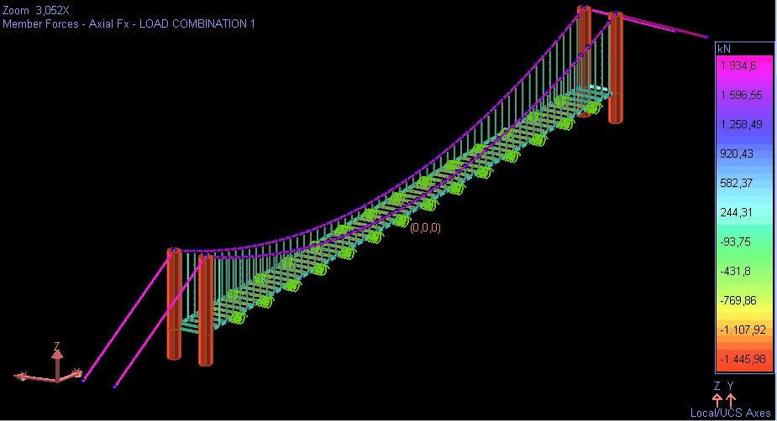

Figure 33. Linear Static Analysis Results of the one with Lateral Cable Supports(Stresses)

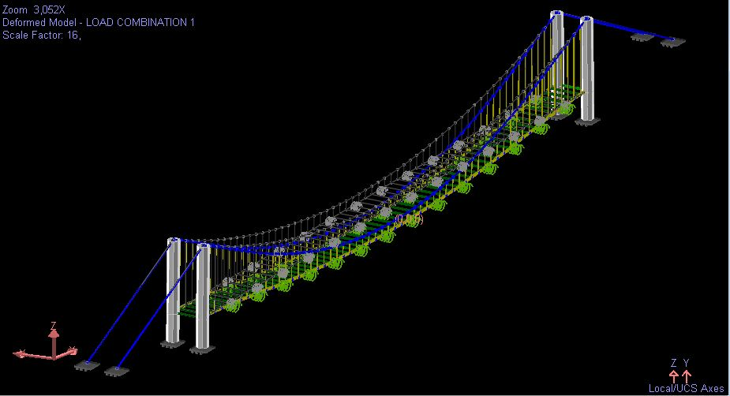

Figure 34. Linear Static Analysis Results of the one with Lateral Cable Supports(Deformations)

As it can be seen in Figure 33 the maximum stresses are found to be in the main cables which are found as 1935 kN after linear static analysis in LARSA4D, it is smaller than the one that is calculated by the hand, but none the less the material selection will be done considering not only the loads but also the serviceability of the bridge, thus this situation does not constitute any problem for the time being.

Moreover, it should be noted that there are no notable deformations in any direction as it can be seen in Figure 34, thus we could say that the lateral support cables are definitely helping the bridge deck to be more stable.

After conducting Eigenvalue analysis, the most critical mode shapes are found as shown in Table 10.

Table 10. Eigenvalue Analysis Results for Dominant Mode Shapes with Lateral Cable Supports

|  |  |  |  |  |  |
| --- | --- | --- | --- | --- | --- |
| Mode Shape | Frequency (Hz) | Period (s) | Per Mass X | Per Mass Y | Per Mass Z |
| M27: f = 3,46, t = 0,2893 | 3,4567 | 0,2893 | 0,0000 | 0,0000 | 52,5926 |
| M29: f = 3,61, t = 0,2772 | 3,6071 | 0,2772 | 0,0000 | 10,7927 | 0,0000 |
| M35: f = 5,5, t = 0,1819 | 5,4986 | 0,1819 | 0,0000 | 21,5046 | 0,0000 |
| M84: f = 15,7, t = 0,0637 | 15,7043 | 0,0637 | 69,0805 | 0,0000 | 0,0000 |
| M88: f = 18,48, t = 0,0541 | 18,4820 | 0,0541 | 14,2008 | 0,0000 | 0,0000 |

As it can be seen in Table 10 almost all the critical mode shapes have higher frequency than 3 s-1, which means that with the lateral support cable addition the vibration problem is seemed to be solved. So, further evaluation is done on the case with the lateral supporting cables and the most critical deformation is found as 219 mm in Z direction, due to axial loads and 18 mm in X direction due to wind load, both deformations have the following limit value according to LRFD Guideline;

$$δ≤\frac{L}{360}=\frac{90000}{360}=250 mm$$

both of the deformations are smaller than the allowable value making this system completely acceptable for usage.

### Conclusion of the Modelling Results

According to, the results obtained from both tests, it can be concluded that the bridge with lateral supporting cables is more stable and can damp the vibrations caused by walking pedestrians, however for other activities like dancing, running and riding a bike can cause a little vibration problem. Although, there exists a possible vibration situation this phenomenon was not tried to be eliminated in our design and modelling, since upon the request of the major of Avanos they, indeed want the new bridge to vibrate in order not to lose any of the tourist attraction, since Avanos is well known and is a tourist destination because of the shaking bridge, so it can be concluded that the obtained results from LARSA4D are acceptable. Finally, as stated before all the results could be found in the Appendix of the report.

## Lateral Supporting Cable Design

As it can be seen in the system geometry part and supported by the modelling results lateral cables provide a more comfortable and safe transportation over Kizilirmak, in below parts this cables will be constructed and it should be noted that this design is inspired by the Millennium Bridge in UK as shown in Figure 35.

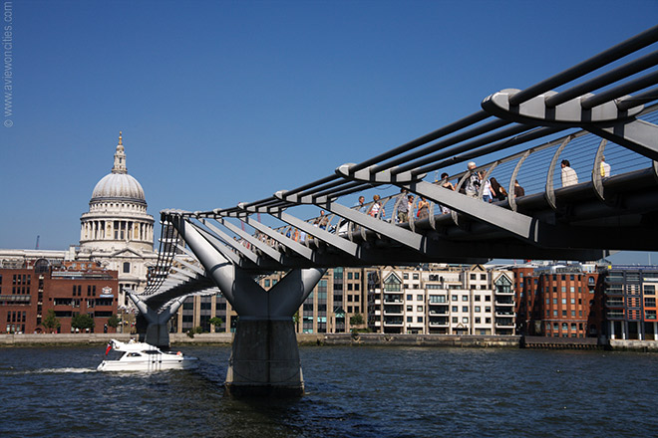

Figure 35. Millennium Bridge Visualization

It should be noted that the longest lateral cable will be 6 meters long and 1 meters long in the middle so the cable lengths for one part of the span can be found as shown below and the other part will exactly be symmetrical to the found part and while the middle portion have a straight-line shape.

$$y=ax^{2}$$

$$x=0→y=0$$

$$x=36→y=9 →a=\frac{1}{144}$$

so, the lengths for the cables can be obtained as follows;

Table 11. Lateral Cable Lengths

|  |  |
| --- | --- |
| **x(m)** | **Length of** |
| 0 | 10,00 |
| 6 | 7,25 |
| 12 | 5 |
| 18 | 3,25 |
| 24 | 2 |
| 30 | 1,25 |
| 36 | 1,00 |
| 42 | 1,00 |
| 48 | 1,25 |
| 54 | 2 |
| 60 | 3,25 |
| 66 | 5 |
| 72 | 7,25 |
| 78 | 10,00 |

Design and the tension on the lateral cables should be arranged in such a way that when the wind load is acting no cable should go on a compression state, this load can be calculated using the maximum displacement, which is 7,57 mm and the selected Stiffness for the cable as follows;

$$F=\frac{E*A}{L}*x$$

Selected EA=19000 kN so,

$$F=\frac{19000}{1000}*7,57=143.83 kN$$

Thus, tensioning each cable with 145 tones should be able to avoid the lateral cables to go in to compression stage.

Now the lateral main cables should be designed like the main cable of the suspension bridge.

As shown in Figure 25,

$$V=\frac{W*L}{2}=\frac{145/6*78}{2}=942,5 kN$$

$$H=\frac{145/6*{78}^{2}}{8*9}=2042,1 kN$$

$$T \left(Resultant Force\right)=\sqrt{{942.5}^{2}+{2042.1}^{2}}=2250 kN$$

So, the main lateral cable will be tensioned to 2250 kN

## Pylon Design

For the pylon, we have 1446 kN axial load and 58.75 kN shear force at the tip of the pylon. These values are taken from the LARSA 4D program. The picture below, Figure 36, shows tension values at the ropes at the tip of the pylon. After calculating the angles between the rope and the pylon, we calculated above values. With 58.75 kN shear we obtain 734.42kNm moment.

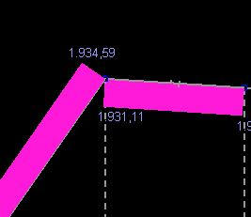

Figure 36. Tension Values at the Main Rope

We assumed HEM450 section with a yield stress of 275 MPa.

$$when K*\frac{L}{r}≤4.71*\sqrt{\frac{E}{Fy}}$$

$$Fcr=\left[{0.658}^{\frac{Fy}{Fe}}\right]*Fy$$

$$when K*\frac{L}{r}>4.71*\sqrt{\frac{E}{Fy}}$$

$$Fcr=0.877Fe$$

$$Fe=\frac{π^{2}*E}{{(\frac{K*L}{r})}^{2}}$$

For strong axis we have both compression and moment;

K=2, L=12500mm, rx=198

$$\left(\frac{K*L}{r}\right)=126.26<4.71*\sqrt{\frac{E}{Fy}}=127$$

$$Fe=123.82 MPa$$

$$Fcr=108.55 MPa$$

$$Pn=108.55*33.54=3640.73 kN$$

$$φPn=3276,66 kN$$

$$\frac{Pr}{Pc}=\frac{1446}{3276.66}=0.44$$

$$when\frac{Pr}{Pc}≥0.2$$

$$\frac{Pr}{Pc}+\frac{8}{9}*\left(\frac{Mrx}{Mcx}\right)≤1.0$$

$$\frac{1446}{3276.66}+\frac{8}{9}*\left(\frac{734.42}{275*6.331}\right)=0,816$$

0.816<1, therefore we are safe in strong axis.

For weak axis we only have compression

K=0.7 L=8000m ry=75.9

$$\left(\frac{K*L}{r}\right)=73.78<4.71*\sqrt{\frac{E}{Fy}}=127$$

$$Fe=362.62 MPa$$

$$Fcr=200.2 MPa$$

$$Pn=200.2*33.54=6717.97 kN$$

$$φPn=6043.47 kN$$

6043.67 kN >>1446 kN therefore we are safe.

## Cable Connection Design

For connecting hanger cables to main cable Pfeifer brands connections are used as it is obtained from the catalogue of the Pfeifer, as it can be seen in Figure 37. For connecting the hangers to the deck steel girders will be used which are bolted to the IPN 200 beam flanges, as shown in Figure 38.

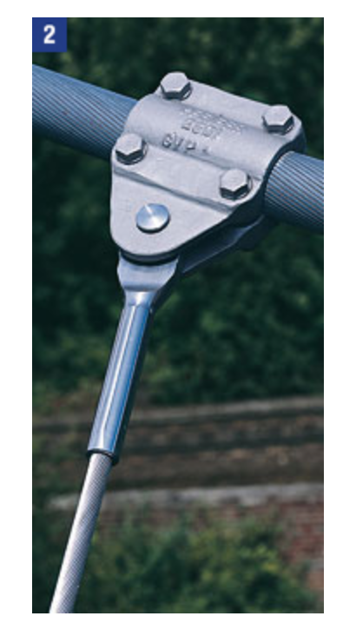

Figure 37.Hanger Cable Connection to Main Cable

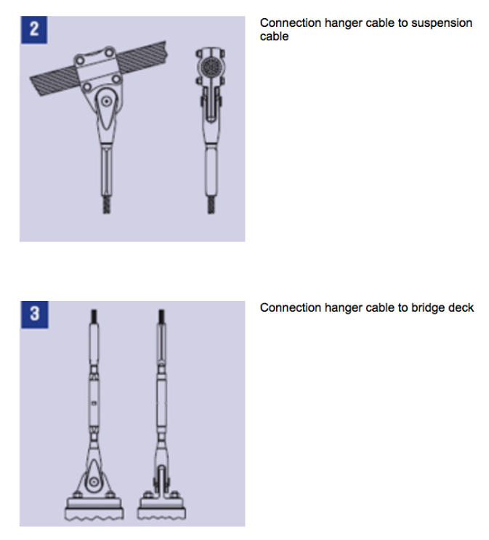

Figure 38. Connection of Hanger Cables

And for the cable fitting PG 55 Type 980 is selected in order to allow the lateral movement of the connection which will reduce the fatigue of the hangers and decrease the maintenance cost of the structure in the long term. 50 mm cables are used which are S355.

Since the maximum load carried by one hanger is found to be 21.18 kN the stress in the connections can be 11 MPa at max, so the connection is safe to carry the loads applied on the hanger cable.

# GEOTECHNICAL DESIGN

In general, foundations have vital role in structures, and its importance is originated from that they transfer loads on the structures to soil underneath them. However, to fulfill this duty in a

trouble-free way, all possible scenarios of relationship between the structure and foundation

should be considered and corresponding foundation design should be made according to the most critical case(s) of these possibilities, that is to say, load combinations most of the times.

In addition to that, relation of the foundation and soil profile should also be examined i.e. settlement calculations etc.

## Load Combination

Generally speaking, approximately 80% of the total vertical load on bridges is originated from the self-weight of the bridges. However, this bridge is an example of suspension bridge and timber used as platform, thus live load in most critical case can be greater than dead load. In addition, thickness of bridge is so small, wind load can be neglected for all stages. To narrow gap;

1.2D+1.6L+1W used as load combination where;

D: Dead load

L: Live load

W: Wind load

## Soil Profile

In order to get idealized soil profile of the site, Standard Penetration Test (SPT) was introduced through 5 different boreholes. However, for all 5 of these boreholes, there are so limited SPT- N values because of that formation of the soil does not allow more penetration. In addition to this, those SPT-N values are around 50. This situation can be interpreted as that soil is too hard to penetrate. This clue may imply something about the features of the soil. In addition to that, since SPT cannot proceed throughout the profile some undisturbed samples were taken via drilling core to analyze them in the laboratory and result in more precise result. With the results of these laboratory tests (Toker Sondaj ve İnşaat, 2012) all relevant features and parameters of the whole soil formations and idealized soil profile were determined by using USCS system (see Figure 408.) According to conducted laboratory tests, soil profile consists of thin fill layer, a layer that contains clayey sand, sandy clay and at the bottom part clayey gravel and clay/silty clay (Ankara Clay) as indicated in Figure 39. First 5 meters of boreholes considered because shallow foundation will be used and beneath 5 meters there is a . Water content and atterberg limits of specimens which were taken from first 5 meters from boreholes can be seen in Table 12 .Further findings of these tests also indicate that there is a stable water table 13.4 m under the ground surface, so there is no need to use ground water table in foundation design since our foundation does not reach there.

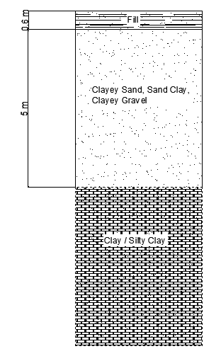

Figure 39. Soil Profile

Table 12. Water content and Atterberg limits

|  |  |  |  |  |  |  |  |  |
| --- | --- | --- | --- | --- | --- | --- | --- | --- |
| **SAMPLES** | **z(m)** | **W**n **(%)** | **γn (kPa)** | **LL** | **PL** | **PI** | **USCS** | **q**u **(kPa)** |
| **SK1** | **1,50** | **23,20** |  | **52,70** | **20,60** | **32,10** | **CH** |  |
| **SK1** | **4,50** | **26,30** | **19,94** | **60,20** | **24,90** | **35,30** | **CH** | **248,60** |
| **SK2** | **1,50** | **25,20** |  | **52,10** | **20,00** | **32,10** | **CH** |  |
| **SK2** | **3,00** | **13,40** |  | **48,70** | **15,80** | **32,90** | **GC** |  |
| **SK2** | **4,50** | **24,20** |  | **62,80** | **26,40** | **36,40** | **CH** |  |
| **SK3** | **3,00** | **23,80** | **20,66** | **56,10** | **16,40** | **39,70** | **CH** | **589,70** |
| **SK4** | **3,00** | **14,40** |  | **33,00** | **12,10** | **20,90** | **SC** |  |
| **SK5** | **1,50** | **12,00** |  | **33,00** | **12,60** | **20,40** | **SC** |  |
| **SK5** | **4,50** | **26,80** |  | **59,30** | **21,00** | **38,30** | **CH** |  |
| **average** | **3,00** | **21,03** | **20,30** | **50,88** | **18,87** | **32,01** |  | **419,15** |

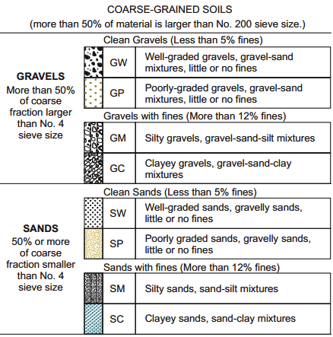

Figure 40. USCS Soil Classification for Coarse Grained Soil

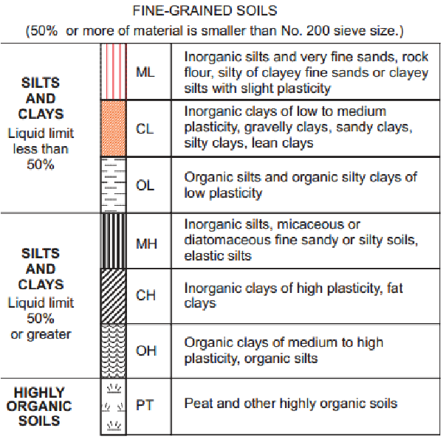

Figure 41. USCS Soil Classification for Fine Grained Soil

SPT N values which were taken from borehole logs are listed below and other values (Table 13) are calculated as follows. These equations are taken from (Ergun, 2011).

$$σ_{v}^{'}=depth* γ_{n}$$

$$C_{N}=9.78*\sqrt{\frac{1}{σ_{v}^{'} (\frac{kN}{m^{2}})}}$$

$$N_{60}=N*\frac{Energy ratio}{0.6}*C_{b}*C_{s}*C_{r}$$

SPT correction factors are 1.00 because of equipment which were used while drilling boreholes and hammer energy ratio is 0.45 in Turkey.

$${(N_{1})}_{60}=N_{60}*C_{N}$$

Table 13. SPT values

|  |  |  |  |  |  |
| --- | --- | --- | --- | --- | --- |
| SPT N VALUE | depth(m) | effective vertical stress (kPa) | CN | (N1)60 | N60 |
| 63,00 | 1,50 | 30,45 | 1,77 | 83,74 | 47,25 |
| 76,00 | 3,00 | 60,90 | 1,25 | 71,43 | 57,00 |
| 50,00 | 1,50 | 30,45 | 1,77 | 66,46 | 37,50 |
| 52,00 | 3,30 | 66,99 | 1,19 | 46,60 | 39,00 |
| 59,00 | 1,50 | 30,45 | 1,77 | 78,43 | 44,25 |
| 66,00 | 3,30 | 66,99 | 1,19 | 59,15 | 49,50 |
| 62,00 | 1,50 | 30,45 | 1,77 | 82,41 | 46,50 |
| 54,00 | 3,20 | 64,96 | 1,21 | 49,14 | 40,50 |
| average |  | average | average | average | average |
| 60,25 |  | 47,71 | 1,49 | 67,17 | 45,19 |

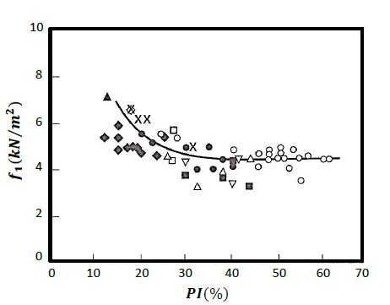

Figure 42. f1 vs PI graph

f1 is taken from Figure 42. f1 vs PI graph. PI was calculated as 32.01 that is why f1 is found as 4.5. Mass shear strength Cu is calculated according to formula below.

$$C_{u}=f_{1}*N_{60} \left(\frac{kN}{m^{2}}\right)=4.5*45.19=203.35 kPa$$

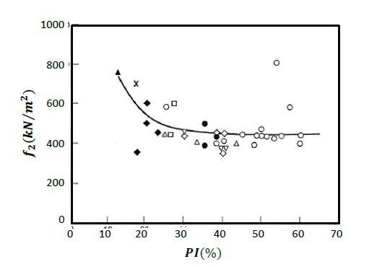

Figure 43. f2 vs PI graph

f2 is taken as 450 from Figure 43. f2 vs PI graph.

$$m_{v}=\frac{1}{f_{2}*N_{60}} \left(\frac{m^{2}}{kN}\right)=\frac{1}{450*45.19}=4.92*{10}^{-5} m^{2}/kN$$

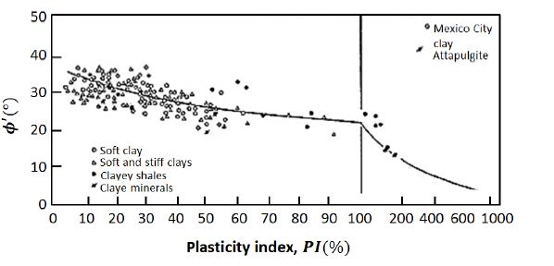

Figure 44. Φ’ vs PI graph

Φ’ is found as 28o from above Figure 44. Φ’ vs PI graph.

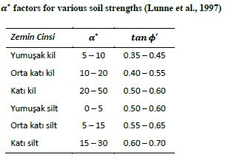

Figure 45. a* factor

a*  factor is found as 29 from Figure 45. a* factor by linear interpolation for tan(28)=0.53.

$$c^{'}=a^{*}* tanϕ^{'}=29*\tan\left(28\right)=15.42$$

$$OCR= \frac{σ_{p}^{'}}{σ_{vo}^{'}}=\frac{300}{20,3*7,5}=2$$

$σ_{p}^{'}$ is found as 300 from geotechnical report (Toker Sondaj ve İnşaat, 2012) by Figure 46. Casagrande’s Method for determining preconsolidation stress. However, there is no consolidation test data for first 5 meters that’s why 7.5 meter depth data are is used in OCR calculations.

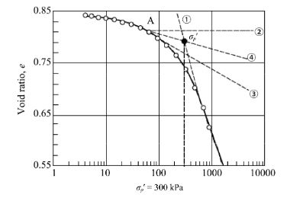

Figure 46. Casagrande’s Method for determining preconsolidation stress

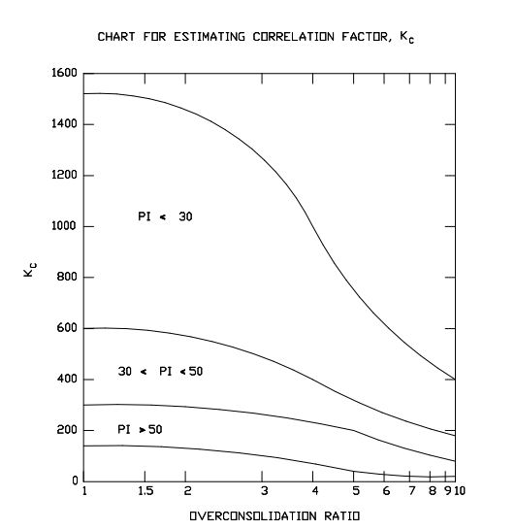

Figure 47. Chart for estimating correlation factor, Kc

Kc is found as 300 from above graph for OCR=2 and PI=32.

By the equation taken from USACE EM 1110-1-1904, Es (Young modulus of soil) is calculated as follows:

$$E_{s}=K_{c}*C_{u}=300*203.35=61000 kPa$$

µoed is taken as 0.7 from below table.

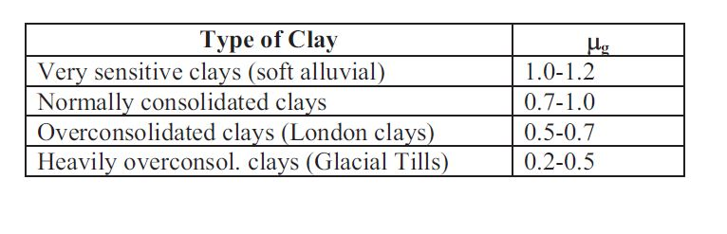

Figure 48. The Skempton and Bjerrum correction factor

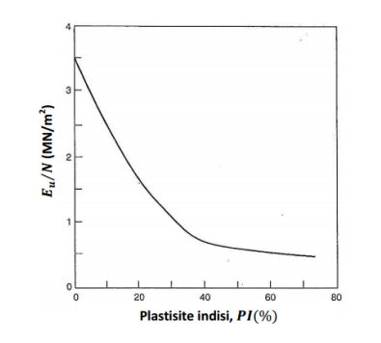

Figure 49.Plasticity index - Eu/N60 relationship (Poulos and Small, 2000)

Eu/N is found as 1.1 from Figure 49.Plasticity index - Eu/N60 relationship (Poulos and Small, 2000), then Eu is calculated as follows:

$$E_{u}=\left(1.1*45.19\right)*{10}^{3}=49709 kPa$$

Calculated clay parameters are listed below Table 14. Clay Parameters.

Table 14. Clay Parameters

|  |  |
| --- | --- |
| Short Term | Long Term |
| Cu=203 kPa | c=15.42 kPa |
| Φ’=28o | Φ’=28o |
| γ= 20.3 kN/m3 | - |
| mv=4.92*10-5 m2/kN | - |
| Es=61000 kPa | - |
| Eu=49709 kPa | - |

## Foundation System

Pylons of bridge have H shape, thus, for each pylon there are 2 piers linked to the foundations. To avoid possible differences in settlement amounts for those 2 piers, it is decided to select combined footing system. Raft foundation cannot be used because piers are too close to each other and from economical view of aspect combined footing system is more reasonable than raft foundation system. Dimensions of foundations determined as 5*5*1 m. Depth of foundation is determined as 2 meters.

## Gross and Net Foundation Pressure

To find out bearing capacity and settlement values, the net pressure that soil would carry should be known. From structural analysis part, vertical force to each pylon is calculated as 1446 kN. Since two pylon connecting to one foundation, on a foundation there is 2892 kN.

$$Gross Foundation Pressure=\frac{Vertical Load+Self Weight of Foundation}{Area}$$

$$Net Foundation Pressure \left(q_{f}\right)=\frac{Vertical load+self weight of foundation-weight of excavated soil}{Area}$$

Self-weight of foundation can be calculated as;

$$Self Weight of Foundation=\frac{(2400*5*5*1)}{1000}=588 .6 kN$$

Thus gross foundation pressure is calculated as follows;

$$Gross Foundation Pressure=\frac{(2892+588.6)}{(5*5)}=139.224 kPa$$

So, net foundation pressure can be calculated as follows;

$$Net Foundation Pressure=139.224-20.3*25/25= 118.924 kPa$$

Since pylons are steel and have small area, when calculating net foundation pressure they can be neglectable.

Please note that no eccentric load on foundations. All forces are vertical from pylon to foundation.

## Bearing Capacity

Safe bearing capacity of foundations on clay is calculated from the Skempton’s equation below. (Ergun, 2011)

$$q_{nf}= c_{u}N_{c}$$

Nc values are found from Skempton’s Chart (1951) Figure 50 as 6.5 for D/B=0.4 .

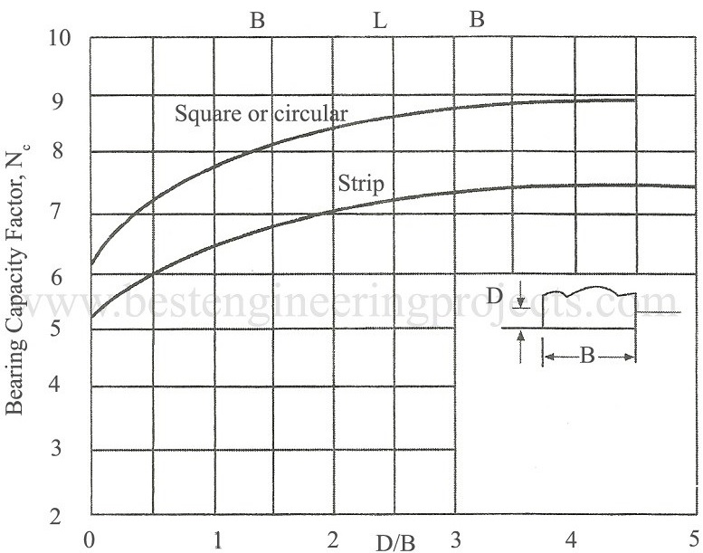

Figure 50. Skempton's Nc Values

$$q_{nf}=203*6,5=1320 kPa$$

and

$$q_{all}=\frac{q_{nf}}{F.S}=\frac{1320}{3}=440 kPa$$

Since allowable bearing capacity of soil is larger than net foundation pressure,that means foundation is safe for bearing capacity.

## Settlement

Settlement is one of the main the criterion in the design of foundations for safety and serviceability. Immediate settlement and consolidation settlement is calculated. Soil under foundation is clay that’s why no need to calculate secondary settlement. Differential settlement is unnecessary too, because each pylon transfer same load to the foundation.

## Immediate Settlement

The vertical displacement (Si) under a loading area carrying a uniform pressure q on the surface of a semi-infinite, homogeneous, isotropic mass (with a linear stress-strain, relationship) can be expressed as (Ergun, 2011) :

$$S_{i}=\frac{q*B}{E}*\left(1-ϑ^{2}\right)*I_{s}=\frac{118.924*5000}{61000}*\left(1-{0.2}^{2}\right)*1.12*0.8=8.38 mm$$

Table 15. Is Values

|  |  |  |  |
| --- | --- | --- | --- |
|  | Center | Corner | Average |
| Square | 1.12 | 0.56 | 0.95 |
| Rectangle, L/B=2 | 1.52 | 0.76 | 1.30 |
| Rectangle, L/B=5 | 2.10 | 1.05 | 1.83 |
| Circle | 1.00 | 0.64 | 0.85 |

For square footing Is value is taken as 1.12 at the center and immediate settlement of a rigid foundation may be approximately taken 0.8 times immediate settlement at the center of flexible foundation (Ergun, 2011). Poisson’s ratio ($ϑ$) is taken as 0.2 for clays (stiff, undrained).

## Consolidation Settlement

One-dimensional compression (Soed) of cohesive soils (such as clay) is calculated on the basis of parameters obtained in the oedometer test. Following expression is recommended:

$$S_{oed}=∑H.m_{v}.{∆σ}^{'}$$

mv is found as 4.92x10-5 (see Table 14. Clay Parameters) and ${∆σ}^{'}$ is calculated from 2V:1H horizontal approach.

By using above approach Soed is found as 14.138 mm. However, this is for one-dimensional. Skempton and Bjerrum observed that actual consolidation settlement of the structures were generally less than the values computed based on oedometer tests. They proposed the following expression (Ergun, 2011) :

$$S_{c}=μ . S_{oed}=0.7*14.138=9.9 mm$$

µ is taken as 0.7 as a representative value (see Figure 48. The Skempton and Bjerrum correction factor) and Sc is found as 9.9 mm.

## Total Settlement

Total settlement is calculated as totaled value of immediate settlement and consolidation settlement.

$$S_{T}=S_{i}+S_{c}=8.38+9.9=18.28 mm$$

By using Settle 3D software total settlement also calculated (Figure 51.Settle 3D values) and the value obtained there is so close to our value which calculated by hand (without software).

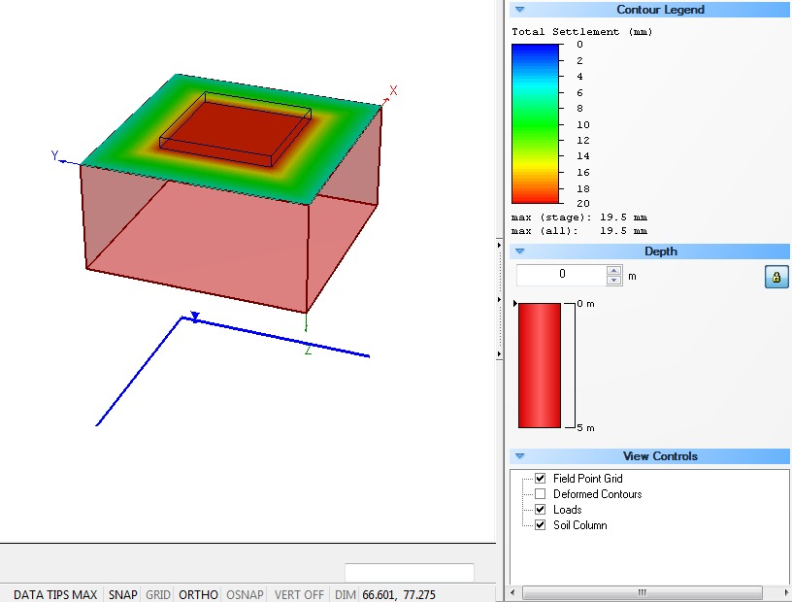

Figure 51.Settle 3D values

## Anchorage Blocks

Main supporting ropes are anchoraged to a concrete block (see appendix) and these block have to withstand against sliding and over-turning.

$${F.S}_{sliding}=\frac{\sum{V*tanδ}+(\frac{2}{3}*c^{'}*b)}{\sum{H}} >1.5$$

$${F.S}_{over-turning}=\frac{\sum{M_{r}}}{\sum{M_{ov}}}>2.5$$

From structural analysis part force in main supporting ropes found as 1935 kN and angle between horizontal axis as 24.23o. According to calculations (Figure 52. Excel Calculations for Block Design for main supporting cables) 7x8x7 meters block is safe for both sliding and over-turning cases.

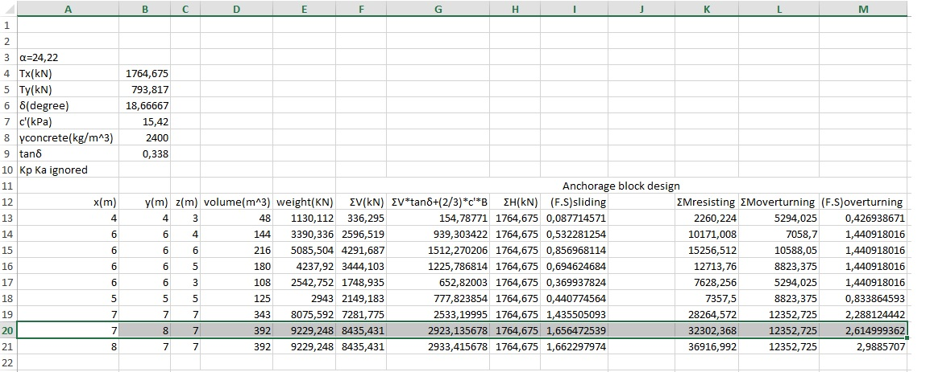

Figure 52. Excel Calculations for Block Design for main supporting cables

Supporting lateral cables are anchoraged to concrete block too. It’s safety against sliding and over-turning calculated in same way. According to calculations (Figure 53. Excel Calculations for Block Design for lateral supporting cables) 8x8x6 meters block is safe for both concerns.

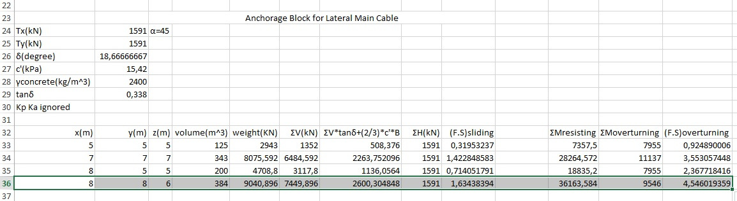

Figure 53. Excel Calculations for Block Design for lateral supporting cables

# MATERIAL SELECTION

Material selection is done according to, the results obtained from the models and hand calculations however, these are not the only parameters that are considered while selecting the materials, upon the more experienced bridge designer and our advisor Prof.Dr. Alp CANER, we have also considered the cycle that the structural elements and chosen much higher stress materials than the minimum required strength, for both increasing

* Concrete (Foundation) C25
* Steel (IPN 200 + IPN300+HEM450) S275
* Timber (Upper + Bottom)
* Main Cable; Bridon Spiral Strands with Nominal Diameter of 150 mm and Minimum Breaking Force of 20800 kN
* Hanger Cables; Bridon Spiral Strands with Nominal Diameter of 50 mm and Minimum Breaking Force of 2400 kN
* Lateral Supporting Cables; Bridon Sprial Strands with Nominal Diameter of 13 mm and Minimum Breaking Force of 171 KN with EA=19 MN
* Lateral Supporting Main Cables; Bridon Spiral Strands with Nominal Diameter of 65 mm and Minimum Breaking Force of 4072 kN
* Connection Fittings; Pfeifer PG55 Type 980, S355

# COST ESTIMATION

For the rough cost estimation, all the volumes of the main equipment have been calculated and the unit prices are found. Unit price of the timber is found to be 507,4 TL/m3 from the Kayalar Kereste and concrete unit price is found to be 153.4 TL/m3 from Sebeltas A.S. Cable prices are Copuroglu Steel and Celsan for main cable 590 TL/m3 and the vertical hanging rope unit price is obtained to be 59 TL/m and finally, the steel unit price is found to be 1.7 TL/kg from LME Steel. Note that most of the unit prices are provided through direct phone calls with the related companies. The price calculations are carried out in Excel Spreadsheet and the results are provided below in tables, and the Total Cost of this project is Estimated to be almost approximately 1000000 TL.

Table 16. Cost Estimation of IPN 200 Beams Used in the Project

|  |  |  |  |  |  |
| --- | --- | --- | --- | --- | --- |
| IPN-200 | | | | | |
| tf (m) | **tw (m)** | **hw (m)** | **bf (m)** | **Area (m2)** | **Length (m)** |
| 0,0113 | 0,0075 | 0,1774 | 0,09 | 0,0033645 | 4 |
| Volume (m3) | **Density of Steel (kg/m3)** | **Mass (kg)** | **Unit Price (TL/kg)** | **Quantity (#)** | **Total Price (TL)** |
| 0,013458 | 8050 | 108,3369 | 1,7 | 59 | 10866,19107 |

Table 17. Cost Estimation of IPN 300 Beams Used in the Project

|  |  |  |  |  |  |
| --- | --- | --- | --- | --- | --- |
| IPN-300 | | | | | |
| tf (m) | **tw (m)** | **hw (m)** | **bf (m)** | **Area (m2)** | **Length (m)** |
| 0,0162 | 0,0108 | 0,2416 | 0,125 | 0,0069 | 90 |
| Volume (m3) | **Density of Steel (kg/m3)** | **Mass (kg)** | **Unit Price (TL/kg)** | **Quantity (#)** | **Total Price (TL)** |
| 0,621 | 8050 | 4999,05 | 1,7 | 2 | 16996,77 |

Table 18. Bottom and Upper Timber Volume Calculations

|  |  |  |  |  |
| --- | --- | --- | --- | --- |
| Bottom Timber | | | | |
| Height (m) | **Width (m)** | **Length (m)** | **Quantity (#)** | **Total Volume (m3)** |
| 0,15 | 0,15 | 90 | 5 | 10,125 |
| Upper Timber | | | | |
| Height (m) | **Width (m)** | **Length (m)** | **Volume (m3)** | **Total Volume (m3)** |
| 0,05 | 3,5 | 90 | 15,75 | 25,875 |

Table 19. Timber Cost Estimation

|  |  |
| --- | --- |
| Timber | |
| Unit Price (TL/m3) | **Total Price (TL)** |
| 507,4 | 13128,975 |

Table 20. Pylon (HEM-450) Cost Estimation

|  |  |  |  |  |
| --- | --- | --- | --- | --- |
| HEM-450 | | | | |
| Length | **Area** | **Mass** | **Price(tl/t)** | **Total Price** |
| 66 | 0,0312 | 16576,56 | 1288,8 | 21363,87053 |

Table 21. Main Cable Cost Estimation

|  |  |  |  |  |
| --- | --- | --- | --- | --- |
| Main Cable | | | | |
| Quantity (#) | **Total Length (m)** | **Unit Price (TL/m) without KDV** | **Unit Price (TL/m) with KDV** | **Total Price (TL)** |
| 2 | 117,7427 | 500 | 590 | 319780 |

Table 22. Vertical Cable Cost Estimation

|  |  |  |  |
| --- | --- | --- | --- |
| Vertical Cables | | | |
| Total Length (m) | **Unit Price (TL/m) without KDV** | **Unit Price (TL/m) with KDV** | **Total Price (TL)** |
| 480 | 50 | 59 | 28329,44 |

Table 23. Concrete used in Foundation Cost Estimation

|  |  |  |
| --- | --- | --- |
| Concrete | | |
| Volume of Concrete (m3) | **Unit Price (TL/m3)** | **Total Price (TL)** |
| 3154 | 153,4 | 483823,6 |

Table 24. Main Lateral Support Cables Cost Estimation

|  |  |  |  |
| --- | --- | --- | --- |
| Lateral Support Main Cable | | | |
| Quantity (#) | **Length (m)** | **Price (TL/m)** | **Total Price (TL)** |
| 2 | 95 | 90 | 17100 |

|  |  |  |  |
| --- | --- | --- | --- |
| Lateral Support Hangers | | | |
| Quantity (#) | **Length (m)** | **Price (TL/m)** | **Total Price (TL)** |
| 2 | 59,5 | 90 | 10710 |

Table 25. Total Cost Estimation of the New Bridge

|  |
| --- |
| TOTAL COST (TL) |
| 916961,4216 |

# Bibliography

American Association of State Highway and Transportaion Officials. (2009). *LRFD Guide Specifications for the Design of Pedestrian Bridges.* USA.

Birand, E. (2011). *Foundation Engineering Lecture Notes.* METU Department of Civil Engineering.

Bridge Turkey Organization. (2016, 05 30). *Turkiye opru Muhendisliginde Tasarim ve Yapima Iliskin Teknolojilerin Gelistirilmesi Teknik Klavuzu.* Retrieved 11 05, 2016, from http://bridgeturkey.org/tasarim-kilavuzu/

Bridges to Prosperity. (2009). Bridges to Prosperity Suspended Bridge Manual. 9-10.

CHAN, A. L. (n.d.). *Natural Frequency.* Retrieved 11 05, 2016, from http://personal.cityu.edu.hk/~bsapplec/natural.htm

ConnectUS. (2015). *Suspension Bridges Advantages and Disadvantages*. (ConnectUS, Producer, & ConnectUS) Retrieved 11 05, 2016, from ConnectUS: http://connectusfund.org/suspension-bridges-advantages-and-disadvantages

Encyclopedia Britannica. (n.d.). *Suspension Bridge*. (E. Britannica, Producer) Retrieved 01 11, 2016, from Encyclopedia Britannica: https://global.britannica.com/technology/suspension-bridge

Encylopedia Brittannica . (2016, 05 10). *Vibration.* Retrieved 11 05, 2016, from Vibration: https://global.britannica.com/science/vibration

Ergun, E. (2011). *Foundation Engineering Lecture Notes.* METU Department of Civil Engineering.

New Mexico Tech. (n.d.). Shallow Foundations : Allowable bearing capacity and Settlement.

Ricciardelli, F. (2007, 12). Lateral Walking-Induced Forces on Footbridges. *Bridge Engineering, 12*(6), 677-688.

Ricciardelli, F. (2016). Deisgn of Footbridges against Pedestrian-Induced Vibrations. *21*(8).

RWTHAACHEN University. (n.d.). *Design of Footbridges.* Reserch Fund for Coal and Steel.

Things of Interest. (2011, 01 10). *Tesla's Earthquake Machine Method.* Retrieved 11 05, 2016, from https://qntm.org/tesla

Toker Sondaj ve İnşaat. (2012). *Ankara - Kazan 7 ada 1 parsel Jeolojik-Jeoteknik Raporu.* Ankara.

Wai-Fah Chen, L. D. (1999). *Bridge Engineering Handbook.* New York: CRC Press.

**APPENDIX**